EXPLORING THE ROLES OF TEACHERS’ CREATIVITY IN TEACHING ENGLISH AT JUNIOR HIGH SCOOL

THESIS

Submitted in partial fulfilment of the requirements for the degree of Sarjana Pendidikan (S. Pd.) in English teaching



By:
Margareta Ayu Widodo
NIM 06010521012

ENGLISH LANGUAGE EDUCATION DEPARTMENT
FACULTY OF TARBIYAH AND TEACHER TRAINING
UIN SUNAN AMPEL SURABAYA
2025

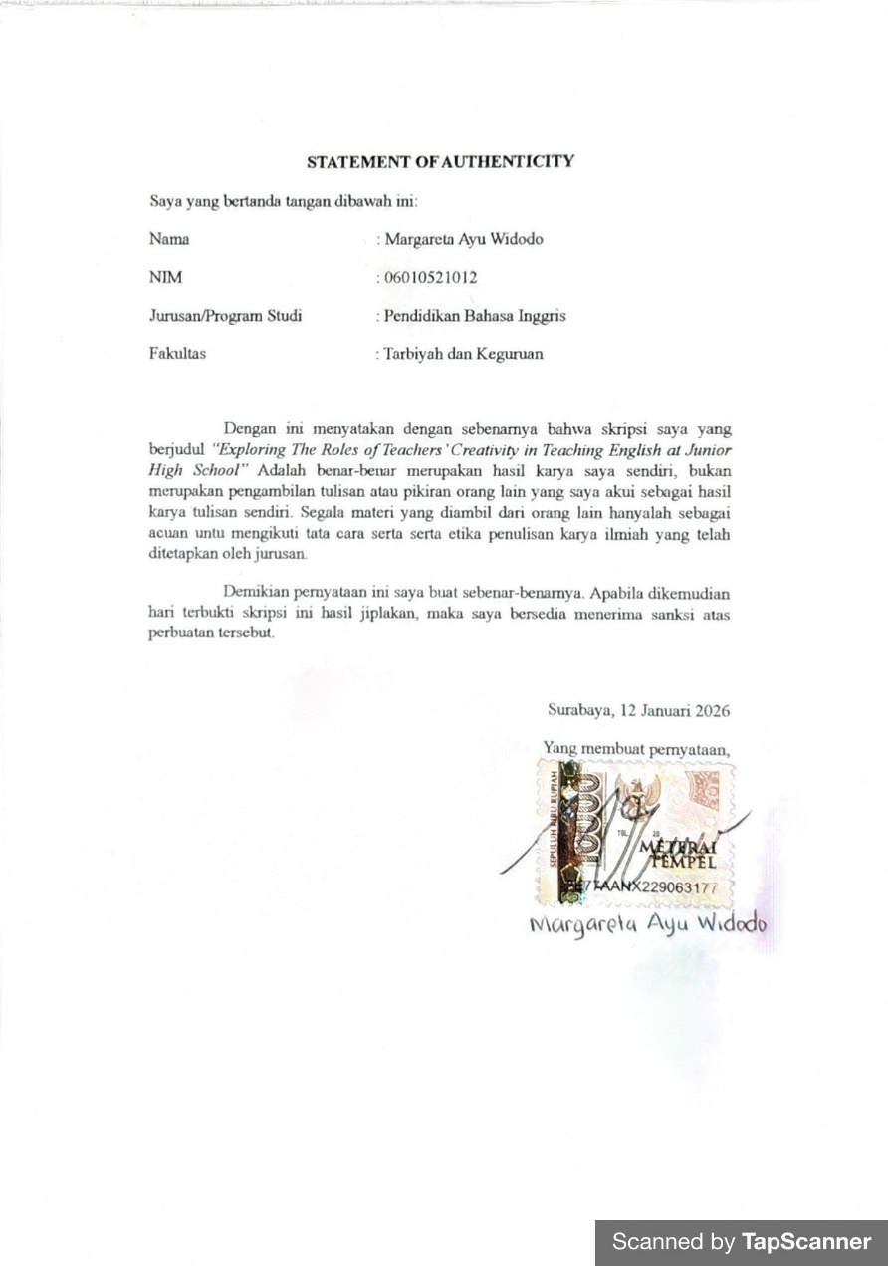
STATEMENT OF AUTHECTICITY

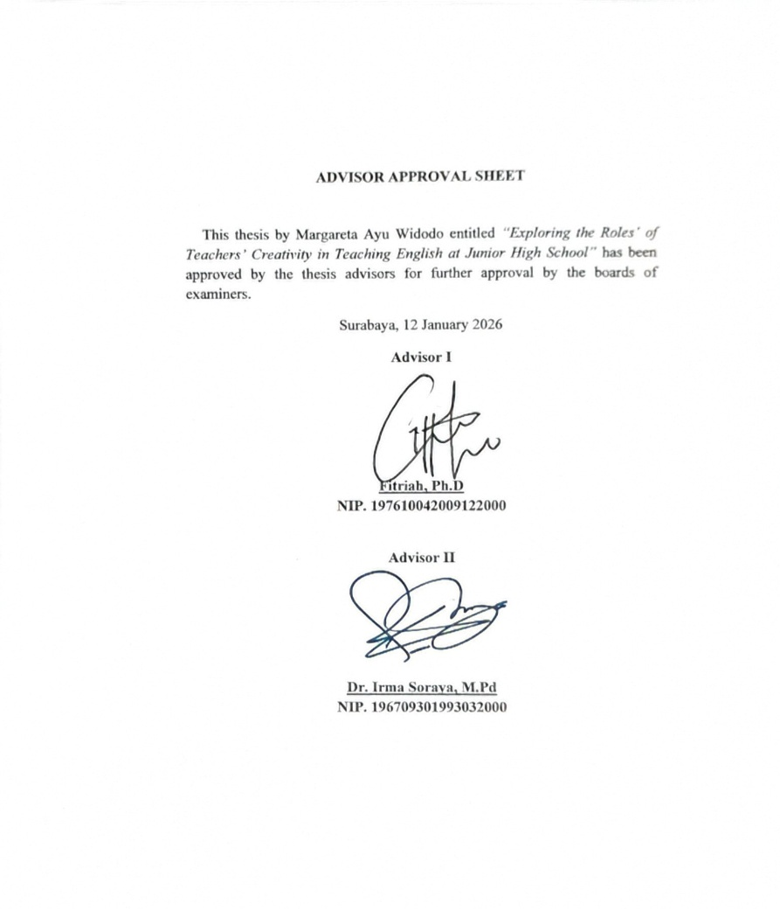
ADVISOR APPROVAL SHEET

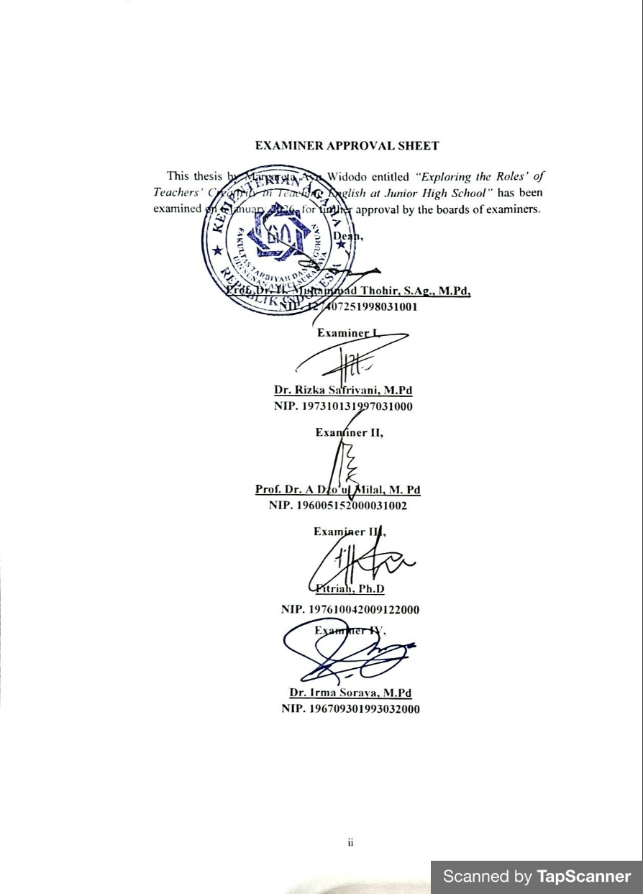
EXAMINER APPROVAL SHEET

ACKNOWLEDGEMENT

First of all, praise and gratitude toward Allah SWT for all of health, opportunity, inspiration, blessing, and infinite grace, so that the thesis discussed which about “Exploring the roles of Teachers’ Creativity in Teaching English at Junior High School” can be completed properly. Without his help and will, all these efforts would be meaningless. Shalawat and salam may always be poured out to the Prophet Muhammad SAW, a true role model and source of inspiration in living a life full of struggle and devotion.
This thesis is submitted as partial fulfilment to obtain for a bachelor degree (S1) in UIN Sunan Ampel Surabaya. To finish this thesis, author recognize has obstacles and difficulties encountered but the assistance, encouragement, and guidance from many, this task can be completed in time.
On this occasion, author would like to give thanks to followings for every valuable time that was dedicated to help author during the data gathering, processing and writing of this thesis.
- Prof. Akh Muzzaki, M. Ag., Grad.Dip.SEA., M.Phil.,Ph.D., as the Rector of UIN Sunan Ampel Surabaya
- Prof. Dr. KH. Muhammad Thohir, S.Ag., M.Pd., as the Dean of the Tarbiyah and Teacher Training Faculty.
- Rakhmawati, M.Pd., as the Head of the English Language Education Department, for her advice and guidance during my time as a PBI student.
- Fitriah Ph.D., who guided and directed the researcher at every stage of the preparation of this thesis.
- Dr. Irma Soraya, M.Pd, my advisor who has patiently provided guidance, direction, and support throughout the process of preparing this thesis.
- My dearest parents, Nur Machilah and Anang Widodo, who has motivated author. Thank you for your unwavering love, prayers, and support.
- My partner, who has become one of my motivations and support to finish this thesis
- My beloved friends who I can't mention one by one, thank you for your support, and always cheering me up with quality time of enjoyable.

ABSTRACT

Widodo, Margareta Ayu. (2025). EXPLORING THE ROLES OF TEACHERS’ CREATIVITY IN TEACHING ENGLISH AT JUNIOR HIGH SCHOOL. Thesis. English Language Education Department, Faculty of Tarbiyah and Teacher Training, UIN Sunan Ampel Surabaya. Supervisors: Fitriah, Ph. D and Dr. Irma Soraya, M. Pd.

Key Words: Teachers’ Creativity, English Learning, Creative Strategies

Creativity in education is increasingly foregrounded in English learning because diverse, interesting activities can attract learners’ attention and sustain engagement. This study examines how English teachers implement creativity in junior high school English classes and what barriers hinder its use. Using a qualitative design, two English teachers at SMPN 22 Surabaya (teaching experience >3 years) participated. Data were collected through semi-structured interviews and classroom observations, allowing triangulation. Guided by theories of teacher creativity, student engagement, and innovative language pedagogy, the data were transcribed and analyzed thematically through coding and theme development. Findings show that teacher creativity is expressed through technology integration (Quizizz, Kahoot, Canva, Padlet, and PowerPoint) and student-centered strategies such as project-based learning, problem-solving activities, and open-ended tasks. These practices encouraged critical thinking, collaboration, and motivation to learn English. However, implementation was constrained by limited access to technology, classroom time restrictions, and students’ varied proficiency levels, requiring teachers to continuously adapt activities and pacing. The study highlights the potential of creative, technology-supported instruction to enhance engagement in EFL classrooms while emphasizing the need for adequate resources and flexible lesson planning.

ABSTRAK

Widodo, Margareta Ayu. (2025). EKSPLORASI PERAN KREATIVITAS GURU DALAM PENGAJARAN BAHASA INGGRIS DI SEKOLAH MENENGAH PERTAMA. Skripsi. Pendidikan Bahasa Inggris, Fakultas Tarbiyah dan Keguruan, Universitas Islam Negeri Sunan Ampel Surabaya. Pembimbing: Fitriah, Ph. D and Dr. Irma Soraya, M. Pd.

Kata Kunci: Kreativitas Guru, Pembelajaran Bahasa Inggris, Strategi Kreatif

Kreativitas dalam pendidikan kini semakin penting dalam pembelajaran Bahasa Inggris karena proses belajar yang beragam dan menarik mampu menarik minat serta menjaga keterlibatan siswa di kelas. Penelitian ini bertujuan untuk mengkaji penerapan kreativitas oleh guru Bahasa Inggris dalam proses pembelajaran serta mengidentifikasi hambatan yang mereka hadapi. Penelitian ini menggunakan desain kualitatif dengan melibatkan dua guru Bahasa Inggris di SMPN 22 Surabaya yang telah mengajar lebih dari tiga tahun dan berfokus pada penerapan pembelajaran kreatif. Data dikumpulkan melalui wawancara semi-terstruktur dan observasi kelas untuk memperoleh pemahaman mendalam sekaligus melakukan triangulasi temuan. Berlandaskan teori kreativitas guru di kelas, keterlibatan siswa, dan inovasi dalam pendidikan bahasa, data dianalisis menggunakan analisis tematik melalui tahap transkripsi, pengodean, pembentukan tema, dan pengelompokan sistematis. Hasil penelitian menunjukkan bahwa kreativitas guru tampak melalui pemanfaatan teknologi seperti Quizizz, Kahoot, Canva, Padlet, dan PowerPoint, serta strategi pembelajaran seperti project-based learning, aktivitas pemecahan masalah, dan tugas terbuka yang mendorong berpikir kritis dan kolaborasi. Praktik ini membantu meningkatkan motivasi dan keterlibatan siswa dalam belajar Bahasa Inggris. Namun, penerapan tersebut menghadapi kendala berupa keterbatasan teknologi, keterbatasan waktu di kelas, serta perbedaan tingkat kemampuan siswa, sehingga guru perlu terus menyesuaikan pembelajaran agar tetap efektif.

MOTTO
‘Life is not a straight line. It bends, twist, stops, and starts again. And these changes are not signs that you are falling. They are signs that you are growing.’
-Anonymous

TABLE OF CONTENTS
Page

STATEMENT OF AUTHENTICITY iii
ADVISOR APPROVAL SHEET iii
EXAMINER APPROVAL SHEET iv
ACKNOWLEDGEMENT v
ABSTRACT vi
ABSTRAK vii
MOTTO viii
TABLE OF CONTENTS ix
LIST OF TABLES xi
LIST OF FIGURES xii
LIST OF APPENDICES xiii
CHAPTER I : INTRODUCTION 1
A. Research Background 1
B. Research Question 4
C. Objective of the Study 4
D. Significance of the Study 4
E. Scope and Limitation of the Study 5
F. Definition of Key Terms 6
CHAPTER II : REVIEW OF RELATED LITERATURE 8
A. Review of Related Theories 8
B. Previous Study 16
CHAPTER III : RESEARCH METHOD 18
A. Approach and Research Design 18
B. Research Subject and Location 18
C. Data Collection Techniques 19
D. Data and the Source of Data 20
E. Research Instrument 20
F. The Technique of Data Analysis 21
G. Checking Validity of Findings 23
H. Research Stages 24
CHAPTER IV : RESEARCH FINDINGS & DISCUSSION 26
A. Findings 26
B. Discussion 39
CHAPTER V : CONCLUSION AND SUGGESTIONS 47
A. Conclusion 47
B. Suggestions 48
REFERENCES 50
APPENDICES 57

LIST OF TABLES

Table Page

4.1 Creativity of Teachers in Teaching English 26
4.2 Challenges that Teachers encounter when applying Creative Strategies 33

LIST OF FIGURES

Figure Page

Figure 4.1 Media PowerPoint 30
Figure 4.2 Video Online 30
Figure 4.3 Video Online 31

LIST OF APPENDICES

Appendice Page

Appendix 1. Intrumen Guideline 57
Appendix 2. Observation Guideline 61
Appendix 3. Result of The Data Collection 63
Appendix 4. Surat Tugas Pembimbing 83
Appendix 5. Instrument Validation Sheet 85
Appendix 6. Approval Sheet of Thesis Proposal 86
Appendix 7. Approval Sheet of Thesis 87

CHAPTER I
INTRODUCTION

This chapter provides information related to the background of the study, a list of research questions, the research objectives, the importance of the study, scope and limitations of the study, and definitions of key terms.

- Research Background
Creativity acts as a driving force in education and is also extremely significant in language learning, where it acts as an activity that works at the level of cognition and is inspired by imaginative engagement in order to produce results that are not only new, but also innovative. In an academic set-up, teachers can be said to be exhibiting creativity if they engage actively in designing and executing diversification in learning processes that go beyond what is usual in a learning set-up. By doing this, they produce new ideas and enhance what is already produced.
Although creativity is widely viewed as essential for building effective learning environments, empirical work on teaching creativity remains comparatively scarce because researchers face methodological constraints while also grappling with the complex cognitive mechanisms that shape creative thinking. Educational literature commonly frames creativity as the capacity to produce original ideas, adapt established concepts, and implement purposeful improvements in pedagogical practice. In classroom settings teachers use creativity to design engaging instruction that strengthens students’ interest and supports better learning outcomes, particularly in high engagement subjects such as English (Revenko et al., 2024).
English often demands substantial teacher creativity because the language operates globally and changes continuously so instruction must adapt through innovative approaches that respond to varied learner histories and proficiency levels (Hidayat & Mason, 2023). Students must manage intricate grammar, broad vocabulary development and accurate pronunciation and these demands frequently become obstacles when teaching relies on rigid routines that fail to sustain interest so teachers who implement creative strategies can activate imagination, strengthen linguistic competence and support deeper emotional and cognitive involvement in learning (Procel et al., 2024).
A widespread misconception attributes difficulties in learning English to low intelligence, yet the more substantial causes often arise from uninspiring instructional practices and limited learning media (Cremin, 2022). When teachers present lessons through monotonous and rigid routines, students tend to perceive English as a difficult and unapproachable subject and this perception gradually reduces motivation and classroom participation. Teacher creativity can counter this pattern by reshaping the learning environment into an engaging space that prioritizes students and supports active involvement (Assulaimani, 2021).
Richard describes teacher creativity as the capacity to actively design innovative learning methods, employ interactive media, and deliver content in engaging forms that remain relevant to learners (Ma, 2022). Teachers who teach creatively keep exploring fresh strategies while optimizing available instructional resources so lessons provide information and also sustain stimulation. Research frequently links approaches such as gamification, storytelling, project based learning, and purposeful use of digital tools with stronger student interest and more active participation, whereas many conventional classrooms still rely heavily on lecture cantered instruction that narrows opportunities for involvement and weakens attention.
Several studies have examined how teacher creativity connects with everyday classroom practice, and Wisnu’s research shows how creative teaching approaches can shape learners’ motivation and participation in language learning (Wisnu et al., 2023). Using a qualitative descriptive design the study gathered evidence from learners and teachers through in-depth interviews, classroom observation and document analysis then the results indicated that teachers who applied gamification storytelling and interactive techniques strengthened engagement and supported gains in language proficiency. The study ultimately argues that creative and engaging classroom conditions encourage active participation and improve overall learning outcomes.
Azizah also evaluated this question quantitatively by analysing the relationship between teacher creativity and classroom effectiveness. A correlational method of research was used to analyse this question; data was obtained from 74 students of various level elements, processed by SPSS analysis to establish a significant relationship between creativity in teaching and successful delivery of instruction to support the question that creative approaches to teaching have a positive outcome on teaching (Azizah et al., 2022).
Despite the evidence that has shown the positive impact of creative teaching approaches in learning institutions, there are a number of challenges that hinder their widespread application in classrooms. This includes a lack of adequate training for teachers in institutions in addition to administrative work that limits time in order to design new approaches that align with technological changes so institutions should work towards ensuring that teachers can implement approaches in a positive way (Adeniyi et al., 2024).
Previous studies have pointed to creative practices in the classroom being an important factor in enhancing learning in the classroom, but there has been a lack of evidence offered in relation to specific strategies being applied to English learning in particular educational settings. The above study intends to investigate a more specific connection between certain learning practices in creativity and learning outcomes in the English language by using tools such as gamification storytelling in the approach of making use of the cognitive characteristics of the students (Moseikina et al., 2022).
Expanding on the discussion on creativity on the part of teachers, it will look at various teaching practices that will enhance levels of engagement within the classroom environment while having an effective direct interest in its application for learning an English language. Teacher creativity on the part of gamification, storytelling, and use with regards to technological tools will be examined on its direct relevance to its use on the learning process of an English language. Although gamification has an extremely high use on engaging courses with its dynamic learning process, storytelling will engage creativity on feelings with regards to an effective cognitive connection on the language process (Balaskas et al., 2023).
Being aware of the significance of creativity in English teaching as highlighted above, this research seeks to explore to what extent creative approaches to teaching can impact English learning. For this purpose, the research shall evaluate a variety of approaches to teaching and their effects on the learning procedure to produce informative knowledge about teaching approaches based on practical observation. Based on the above arguments introduced for this research topic, this research poses an observation with the topic of “Exploring the Roles of Teachers’ Creativity in Learning English”.

- Research Question
The background information provided above serves as the foundation for the questions of research:
- What creativity do teachers perform in learning English?
- What are the challenges in applying creative learning strategies in English language teaching?

- Objective of the Study
The present study’s objectives are:
- To analyse the creativity that teachers do in learning English.
- To identify the challenges faced by teachers in applying creative learning strategies in English language teaching.

- Significance of the Study
The person conducting the study wishes that the research conducted has gained significance:
- For the teacher
The present research provides evidence as to how creativity takes shape in English language learning and at the same time elaborates on practical ideas for innovative strategies that can strengthen students’ interest. This study provides reflective input for enhancing instructional quality and lays a basis for teacher professional development with a focus on creative approaches in the teaching of the English language.
- For the other researchers
The current research contributes to the scholarly discussion of teacher creativity and will serve as a reference point for further investigations in research looking into its role in learning, especially in teaching English.
- For police maker
This study provides practical input for policy-makers at the school level, such as school principals, in formulating policies at the school level and programs for professional development that enhance creativity in teaching.

- Scope and Limitation of the Study
The analysis background provides information on its scope and limitations, started below:
- Scope
In the given study, the concept of teacher creativity during English learning lessons within a second-level education setting where English is a foreign language will be explored in this research. In the analysis, the researcher will examine the way creative approaches can be applied by the teacher in handling English lessons and come up with a comprehensive analysis of the impact these methods have on sustaining interests among pupils when learning English. The topic further encompasses the influence these methods have on the speaking, reading, and writing competencies among pupils as a way of arriving at a relevant conclusion related to creative English learning methodologies.
- Limitation
This study concentrates on three dimensions of teacher creativity in English learning namely designing and preparing instructional materials, applying a range of teaching methods and using instructional media effectively. The research prioritizes these dimensions because they occur frequently in classroom practice and directly shape student engagement as teachers' creative decisions often determine how actively learners participate. By focusing on these selected area the study seeks a more precise explanation of how creative strategies can strengthen student interest. Barriers to implementing creative instruction can emerge from internal and external conditions as well as teacher confidence to try unfamiliar approaches so the analysis limits its attention to teacher driven creative practices inside the classroom while acknowledging that wider institutional systemic and socio-cultural influences on student interest fall outside the scope of this study.

- Definition of Key Terms
This section presents the operational definitions of key terms used in this study. Clarifying these terms is important to ensure a shared understanding of the concepts discussed and to avoid misinterpretation. The definitions below are based on relevant literature and are aligned with the context of this research.
- Teachers’ creativity
Nasie defines teacher creativity as the capacity to generate innovative approaches to instruction and to respond effectively to challenges that arise either within the learning process or from external conditions (Rapik, 2022). In this study teacher creativity is conceptualized as educators' ability to create and implement new imaginative teaching strategies and methodologies that enrich students' learning experiences.
- Challenges
Challenges as obstacles or difficulties that emerge during teaching and learning and may disrupt communication, student engagement or lesson delivery (Wijaya et al., 2021). In this study, challenges refer to the constraints and obstacles that hinder teachers from effectively applying creative learning strategies in EFL classrooms, including pedagogical, student-related, and contextual factors that may reduce the effectiveness of creative instruction.
- EFL Classrooms
An EFL classroom is a learning environment where English is taught as a foreign language to students whose first language is not English, and English is not used for daily communication (Chen & Yuan, 2021). Instruction focuses on developing students’ reading, writing, listening, and speaking skills. In this study, EFL classrooms are defined as organized learning settings for non-native speakers where teachers use teaching strategies suited to students’ needs to improve English proficiency and communication, while also introducing cultural and contextual understanding.

CHAPTER II
REVIEW OF RELATED LITERATURE

The second section discussed the overview of related theories about creativity in English language teaching. This section presents the topics about teachers’ creativity in education; strategies to engage students’ interest; and creativity in language teaching.

- Review of Related Theories
- Teachers’ Creativity in Education
In education, creativity matters not only for students but also for teachers because an educator shapes the learning experience through innovative thinking that keeps instruction engaging, stimulating and dynamic while still meeting intended learning objectives. Fadzil supports this view by emphasizing that creative teaching functions as an essential competence for educators because it allows teachers to cultivate curiosity and strengthen student capacity for original thinking through innovative instructional approaches (Fadzil et al., 2022).
There have been different views concerning creative teachers, and Murdiana et al. (2020) defines it as the “ability to convey ideas by using new or modified methods,” while Huda states that these teachers "contribute new ideas and methods to the class so that they transform learning into experience," and therefore, these kinds of teachers "transform learning into experience because they use different teaching techniques and methods to assess learning. This definition encompasses the role of educators to use different teaching methodologies to foster learning among students by creating a learning environment inside and outside the class to carry out the teaching plans effectively, hence, it can be said that the definition revolves around “developing a lesson plan and creating a positive learning environment that fosters learning,” since it deals with giving new life to learning through new methods and techniques, including creating new learning resources and a positive learning environment.
For effective accomplishment of education goals, teachers should use creativity. Moraiz describes creativity in the context of teachers as a professional quality or habit that helps teachers become risk-takers to induce dynamic class environments with some degree of unpredictability (Žydžiūnaitė & Arce, 2021). Such class environments might help children become more autonomous in their actions and enhance their confidence
These approaches show that the role of teacher creativity is very important in supporting meaningful and effective learning, because teachers need innovative strategies that enable them to attract students’ interest and maintain it in the classroom environment. This is because students will find the learning process inspiring rather than monotonous. Creative teaching also makes learning feel inspiring and relevant rather than routine. ERIC defines creative teaching as designing and implementing innovative, original, or unconventional teaching methods that include developing unique curricula and adapting pedagogical strategies to meet individual learning needs (Chen & Yuan, 2021). Ultimately, the effectiveness of creative teaching relies on how the teacher delivers knowledge and arranges the learning and teaching environment to accomplish educational goals (Reilly et al., 2011).
When teachers fail to foster creativity during instruction, they often produce repetitive and uninspiring learning experiences that reduce students' engagement and concentration. As lessons become monotonous many students struggle to sustain interest and their motivation to learn can gradually decline. Teachers can counter this pattern by creating dynamic stimulating classroom conditions and applying varied instructional strategies that strengthen student interest and support academic quality (Alghamdi & Khadawardi, 2024).
Mulyasa (2007) identifies seven pedagogical approaches that teachers can employ in classroom instruction:
      - Self-Esteem Approach
Teachers should make self-esteem and self-confidence key aspects of student development when teaching a subject. They should also help learners to build character and emotional well-being in order to secure learning that is balanced.
      - Creative Approach
The above strategies facilitate innovative problem-solving skills through brainstorming activities such as question-based learning and role-playing exercises that encourage critical thinking and enhance imagination.
      - Value Clarification and Moral Development Approach
This method focuses on personal development using a holistic and humanistic approach to encourage students toward self-actualization and improve moral and ethical perceptions.
      - Multiple Talent Approach
The goal is to optimize and develop the different potentials of each student so that artistic and academic skills are given equal opportunity to grow and develop.
      - Inquiry Approach
Students are encouraged to engage in intellectual inquiry through active cognitive engagement to uncover scientific concepts and principles.
      - Pictorial Riddle Approach
By integrating visual problem-solving tasks into small group discussions this approach stimulates curiosity, enhances critical thinking and strengthens creative reasoning.
      - Synectic Approach
This technique emphasizes cognitive flexibility by encouraging students to explore unconventional ways of thinking, unlock intellectual potential and refine creative ability (Nurdiyanto et al., 2024).
Creativity represents a fundamental expression of human existence and functions as a driving force that enables individuals to improve their quality of life. Stemberg outlines several characteristics of creative individuals including originality, independence, willingness to take risks, intrinsic motivation, curiosity, humour, a preference for complexity and novelty, appreciation of art and openness to experience (Sternberg et al., 2023). Creativity also develops through multiple influences that shape its growth and differentiate people from one another and these influences can be grouped into aptitude related and non-aptitude related factors.
Creativity also functions as a key component of teacher professional competence because effective teaching depends on a combination of pedagogical skill, professional attitude and strong subject matter mastery. The quality of teaching and learning closely reflects teacher professionalism and without it schools cannot achieve educational objectives optimally. A professional teacher therefore demonstrates specialized expertise and pedagogical proficiency so learning outcomes align with intended educational goals (Darling-Hammond, 2021).
- Creativity in Language Teaching
Creativity involves the capacity to use dialectical reasoning, build connections through analogy and metaphor, draw on intuition and inspiration, apply intellectual processes and employ multiple cognitive representations along with specialized perceptual mechanisms to identify problems and generate solutions. Ryhammer and Brolin argue that creativity is necessary for cultivating an innovative mindset in both educators and students (Arooj et al., 2021). Developing teacher creativity provides a basis for transformative teaching methodologies that enable educators to motivate learners to explore and expand their linguistic competence. Gregerson (2007) also suggests that teachers can support this process by adopting flexible communicative approaches strengthening intrinsic motivation and applying varied pedagogical techniques that have been shown to enhance student creativity (Huang et al., 2022).
Integrating creativity into pedagogy requires dynamic instructional strategies that engage students actively. Even when immediate gains do not always appear, teachers still need to provide autonomy for creative thinking because it supports cognitive and linguistic development. Creative teaching strengthens innovative thought while enabling students to explore personal skills, talents and knowledge. Educators therefore carry a dual responsibility as they deliver knowledge and also facilitate imaginative and creative thinking. Building creativity in the classroom demands sustained time and effort because professional teachers must integrate innovation with established instructional responsibilities in an effective way.
Creativity strongly influences student achievement particularly in contemporary language instruction where curriculum goals increasingly emphasize expansion and the development of learner creativity. Approaches such as communicative language teaching and interaction-based learning intentionally cultivate creative cognition and problem solving through active language use. When teachers create supportive classroom conditions that help students manage language acquisition challenges learners gain greater space to think creatively and participate more confidently. Richard also argues that progress in language learning emerges from the synergy between teacher creativity and student creativity which strengthens pedagogical effectiveness and sustains engagement (Ferris & Hedgcock, 2023).
In the Oxford Advanced Learner’s Dictionary, the term strategy denotes a well-structured plan developed to achieve a specific goal and it also refers to the skilful use of methods to carry out that plan effectively especially in complex situations such as military operations. In education strategy represents the deliberate approach that educators and students apply during the learning process to reach predetermined objectives. A teaching strategy therefore functions as a systematically designed plan or set of instructional activities directed toward a particular educational outcome.
In language teaching creativity refers to teachers’ ability to design and apply innovative instructional strategies that strengthen learners’ language skills while making the learning process more engaging and enjoyable. Teachers increasingly adopt creative contemporary approaches that align with technological development, varied learner needs and current educational trends. Common modern creative methods used today include (Nuriddinovna, 2025):
- Project Based Learning encourages students to collaborate on real world projects, solve problems and use language in authentic contexts.
- Gamification integrates game elements into instruction to increase motivation and strengthen student engagement.
- Blended Learning combines face to face instruction with technology to create flexible dynamic learning experiences.
- Task Based Language Teaching emphasizes authentic tasks that motivate students to communicate directly in the target language.
- Storytelling with Digital Tools uses technology to create interactive narratives that enrich language learning and support active participation.
Although creative learning strategies offer clear advantages in language teaching several barriers still limit effective implementation. Wijaya et al. (2021) define challenges as obstacles or difficulties that arise during teaching and learning and that can disrupt communication reduce student engagement or weaken lesson delivery while Gulikers et al. (2004) explain that these barriers often emerge from a combination of internal and external factors such as:

- Lack of Resources and Infrastructure
Limited resources tend to be a significant obstacle in implementing creative learning methods closely associated with Charles, as teachers may not have consistent access to the digital tools, technology, and teaching materials needed to implement approaches such as gamification, project-based learning, or blended learning. In addition, many schools, especially in developing countries, face technological infrastructure factors that limit the feasibility of implementing innovative teaching methods.
- Teacher Resistance and Lack of Professional Development
A teacher who embraces traditional methods of instruction may refuse to implement creative methods because the teacher believes that creative methods will require a great deal of time and expertise. Teachers may feel constrained by a lack of professional development concerning creative methods of instruction and may not be afforded the opportunity or freedom to implement these methods effectively.
- Curriculum and Assessment Constraints
Strict curriculum frameworks and a focus on standardized testing can present barriers as well. “Innovative approaches to teaching languages through task-based teaching and project-based learning require a certain flexibility that a rigid curriculum framework would make difficult.” Moreover, there may be a drive to deliver a specific result that would hinder a more creativity-based or engagement-driven teaching method. Moreover, there may be a drive to deliver a specific result that would hinder a more creativity-based or engagement-driven teaching method.
- Diverse Student Needs
Most of the creative approaches to learning involve student-centered approaches that require teachers to be sensitive to different needs and interests of learners. When teachers have large classes with heterogeneous students, they may not easily create opportunities for differentiation and time constraints may come into play. Another problem that teachers encounter is catering to all students through their teaching endeavours when they have different ability and motivation levels.
- Time Constraints
Meanwhile, creative strategies, such as project-based learning or gamification, generally require much more intensive planning and implementation in the classroom than traditional teaching methods. In addition, teachers are sometimes constrained by the demand to cover the material in a limited amount of time; this naturally limits the application of exploratory methods. Given these constraints, a teacher may prefer a conventional approach because it seems more appropriate for completing the curriculum. In addition, teachers are sometimes constrained by limited time to cover the material within a specified time frame; this naturally limits the application of exploratory methods.
- Lack of Institutional Support
In some educational institutions, school management may provide minimal support in implementing innovative learning approaches due to a lack of knowledge and concerns about deviating from conventional techniques. In such situations, a lack of leadership support can make teachers feel isolated when implementing new techniques and may become an obstacle to the implementation of innovative strategies.
- Assessment of Creativity
Assessing creative approaches in learning is often challenging because conventional assessment methods are not always able to measure the overall creative potential of students. Creativity is a complex process that cannot always be measured through conventional assessment methods and learning evaluations. This requires new assessment approaches that are more practical, reliable, and in line with innovative approaches in teaching, formative assessment, peer assessment, and performance assessment.

- Previous Study
Current research can be categorized in the established field of study that focuses on analysing the complexity of teachers’ creative work with the aim of increasing students' interest in learning English. Previous studies have covered various aspects of creative teaching in the classroom, such as:
Hestika et al. examined the contribution of creativity taught by teachers in influencing student learning interest for English learning for Grade II students of SMP Negeri 2 Tinambung (Hestika et al., 2021). The research probed two questions amongst students by analysing student responses to English learning and exploring the impact of creativity taught by teachers to influence their learning interest for English subjects. The descriptive qualitative research design surveyed a population of 25 Grade II students of SMP Negeri 2 Tinambung to sample respondents for class B while using interviews and questionnaires to gather information for analysis to conclude that creativity taught by teachers highly influences students' learning interest for English subjects as it instils more enthusiasm for teaching with an enhanced desire to learn English.
Wisnu et al. (2023) explored the importance of teacher creativity in motivating language learners to become interested in language studies (Wisnu et al., 2023). Using a descriptive qualitative research design and purposive sampling techniques for gathering data and viewpoints from language learners and teachers who appreciated the benefits of creative teaching methods in language classes in terms of grasping the attention and motivation of language learners to become fluent in language studies. The research findings indicated the significance of creative teaching techniques like gamification and storytelling in grasping the attention of language learners to become motivated and self-confident to express themselves in language studies and a positive environment of language studies that encourages language learners to take responsibility for language studies.
Zhi and Wang studied how EFL teachers’ professional success comes along with their practicing of loving pedagogy and the degree of their creativity in modelling the relations by means of structural equation modelling. Analysis positioned creativity as one of the most important mediating variables that linked loving pedagogical practice with professional success. In such a way, the results indicated that teachers who used emotional care and empathy as the core constituents of loving pedagogy tended to be more creative in their teaching methods, while such an approach was generally associated with better academic performance and greater student engagement in the classroom. Thus, this research underlines the importance of developing teachers’ emotional intelligence together with innovative thinking for the sake of optimized learning outcomes (Zhi & Wang, 2023).
Ma’s research investigated the effects of teacher self-efficacy and creative teaching in class influencing EFL learners’ success in academics. In this research conducted using the quantitative research design and analysis of findings using statistics, it was visible that teachers with a better level of self-efficacy tended to work more on creative student-centred teaching in class. Such activities included language in context activities, group work activities, and multimedia activities in class and they affected levels of academic success in EFL learners positively and contributed to successful English language acquisition (Ma, 2022).
Umam et al. examine the aspect of teachers’ creativity and student interest by focusing on a qualitative case study among some experienced English teachers. Researchers in this study use interviews, observation, and document analysis in an effort to identify how experienced English teachers can sustain student interest and enthusiasm. The findings show that encouraging creative motivational approaches among experienced English teachers was achieved by using proper humour, collaborative activities, real-life context when teaching language, as well as personal support. Drawing on these findings, this article concludes by identifying how these measures enhance student engagement, along with encouraging a positive emotional environment in class, as is required for sustained learning motivation in English (Umam et al., 2023).

CHAPTER III
RESEARCH METHOD

The third section discusses the overview of research methods about creativity in English language teaching. This section presents the topics about approach and research design, research location, data and sources of data, research instruments, data collection techniques, data analysis techniques, validity of findings and research stages.

- Approach and Research Design
This study adopted a qualitative design to explore teachers’ creativity in English language teaching through semi-structured interviews and classroom observations. This approach was appropriate because teacher creativity is a complex and context-dependent phenomenon that cannot be fully captured through numerical measurement alone. Qualitative methods enabled the researcher to examine how teachers interpret creativity, why they choose particular strategies, and how these strategies are enacted in real classroom situations. Interviews provided insight into teachers’ beliefs, intentions, and experiences, while observations allowed the researcher to verify and describe how creative practices appeared during instruction. Consistent with Creswell’s view, qualitative inquiry supports an in-depth understanding of a phenomenon by focusing on participants’ perspectives and the meanings they attach to their actions (Creswell, 2012). Therefore, a qualitative approach best matched the aim of this study by capturing the rich, detailed, and situational nature of creative teaching in EFL classrooms.

- Research Subject and Location
This study explored how teachers’ creativity can increase students’ interest in learning English and examined the challenges teachers face when implementing creative strategies. The research was conducted at SMPN 22 Surabaya and involved two English teachers as the main participants. This school was selected because it provides an active English learning environment and allows the researcher to access classroom activities for direct observation. In addition, SMPN 22 Surabaya represents a typical public junior high school context, making the findings relevant to similar EFL settings. The observed classes were chosen purposively to ensure they matched the focus of the study. The selected classes were those taught by the participating teachers and showed regular English instruction where creative strategies could be implemented and observed. This allowed the researcher to examine teacher creativity and classroom challenges in real teaching situations. Participants were selected based on specific criteria. The teachers were required to have at least three years of teaching experience, as this duration is considered sufficient for teachers to develop stable teaching practices, classroom management skills, and a deeper understanding of students’ learning needs. Moreover, the teachers needed to actively apply creative approaches in their English classes so that the study could capture concrete examples of creative teaching as well as the difficulties encountered during implementation.

- Data Collection Techniques
This study used classroom observation and teacher interviews to collect data. Classroom observation was conducted to examine how teachers implemented creative learning strategies during English lessons, including the teaching phases, classroom activities, and teacher–student interactions. Through observation, the researcher identified the extent to which creative teaching practices were applied to support the learning objectives. In addition, semi-structured interviews were carried out to obtain deeper information about teachers’ perspectives, reasons for using creative strategies, and the challenges they faced during implementation. Using both techniques supported data triangulation, allowing the researcher to compare what teachers said in interviews with what occurred in actual classroom practice. This strengthened the credibility of the findings and ensured that teacher creativity and its challenges were addressed comprehensively.

- Data and the Source of Data
To answer the research questions about teachers’ creative practices and the challenges they face, this study used two main sources of data: semi-structured interviews and classroom observations. The first set of data was obtained from semi-structured interviews with two English teachers. These interviews explored the teachers’ creative strategies to increase students’ interest in learning English, their reasons for using such strategies, and the challenges they encountered during implementation. The second set of data came from classroom observations. The observations documented how the teachers applied their creative strategies in real teaching situations, including instructional methods, teacher–student interactions, student responses, and the overall classroom environment. Data from interviews and observations were then compared and combined to provide a more complete and credible understanding of teacher creativity and the challenges of applying creative learning strategies in EFL classrooms.

- Research Instrument
The research instruments for this study consisted of two main tools, namely the interview protocol and the observation guidelines.
- Interview Protocol
The interview guide was tailored with a set of questions aimed at investigating the practices adopted and challenges faced by the teachers in enhancing their students’ learning interest for English learning using creative approaches. The researcher was able to craft the teacher questions based on three concept views related to teacher creativity in education approaches aimed at enticing student interest and teacher creativity in language learning approaches. The guide was aimed at investigating the approaches employed by the teachers utilizing creative learning approaches and outlining challenges faced during the learning process.
- Observation Guidelines
The research applied guidelines for observations to record and track how teachers were able to apply creative teaching methods in a classroom setting. The field notes were centred on observing teachers at various stages of a lesson such as opening, main activity, and the final closing part of a lesson. The instrument for observations was employed and tailored from the same theoretical models applied in designing an interview schedule. Through a classroom observation, data on challenges that arose from creative teaching approaches was collected.

- The Technique of Data Analysis
In this study the researcher analysed data drawn from two instruments namely the interview protocol and the observation guidelines. The study applied thematic analysis to identify, analyse and report recurring patterns and themes across the dataset.
- Interview Data
- Transcription
Transcription involved recording all interviews with the English teachers and producing verbatim transcripts to maintain accuracy.
- Familiarization
Familiarization required the researcher to read the transcripts repeatedly to build a deep understanding of the interview content.
- Initial Coding
Initial coding used open coding to mark recurring ideas, issues and patterns in teachers’ responses and the researcher generated codes such as insecure students limited facilities and project-based strategies.
- Theme Development
Theme development combined related codes into higher level themes such as teacher strategies for building self-esteem curriculum constraints and the use of digital media to increase motivation.
- Categorization
Categorization organized these themes into broader categories to present a comprehensive picture of teachers' practices and the challenges they faced when applying creative learning.
- Observation Data
- Rereading Observation Notes
The researcher reread the observation notes repeatedly to capture the overall classroom dynamics and build a clear picture of how the lesson unfolded.
- Coding Classroom Events
The researcher then coded key classroom events by labelling important moments with analytic codes such as student engagement strategy when the teacher conducted an ice breaking activity and digital media integration when the teacher used PowerPoint and Quizizz.
- Grouping into Themes
Next the researcher grouped related codes into broader themes such as strategies for maintaining student focus use of technology and time constraints.
- Analysis and Interpretation
The analysis moved beyond description by interpreting how creative strategies operated during instruction and identifying obstacles that emerged during implementation and for example interview data suggested that digital media increased motivation while observation data showed that limited internet access kept some students passive.
- Triangulation with Interview Data
Finally the researcher triangulated observation findings with interview evidence to strengthen validity and for instance teachers reported that Quizizz increased enthusiasm and classroom observation confirmed that most students participated actively although a small number remained passive.
The study used thematic analysis techniques on data collected using the guidelines for observations. The researcher first read the collected data thoroughly in order to understand the context of learning in the classrooms when the learners were taken through the strategies of creative learning. The researcher highlighted key activities that demonstrated engagement and involvement in class, denoting the application of creativity in teaching by the teachers. Based on the highlights, the researcher analysed the data collected from the observations in order to establish the influence of the teaching strategies on engagement of learners in learning English. The data from the observations provided rich information on the influence of the teaching strategies in the classrooms.

- Checking Validity of Findings
For the validity of the data, the researcher triangled the data by comparing it with evidence gathered from the research interviews with two teachers. The researcher compared the evidence gathered from the research interviews with evidence gathered from observation with the objective of validating whether the perceptions of the two teachers match with the level of engagement recorded among the students during the learning process facilitated by the introduction of activities related to creative learning with the objective of arousing the students’ passion for learning English.
For instance, when the teacher talked about the problems encountered while implementing creative learning approaches in class to improve motivation, the validity of the claim was checked by the researcher through observation of the class to ensure that the approaches were correctly implemented in class by the teacher. Furthermore, the two pieces of evidence can be compared.
Finding the same patterns in the results of the interview findings and the observation helped in increasing the validity of the study. Triangulation also served as a method of validating the study that may experience biases in the event that the study relied entirely on only one source of data. The study combined the subjective perceptions of the teachers in the interview with the observation evidence in class in order to create a comprehensive perspective of the challenges that the teachers encountered in the application of creativity in class to encourage the learners to get interested in learning the English language.

- Research Stages
The study investigated the function of teacher creativity in boosting their students’ interest in learning English as a means of establishing the challenges faced by teachers when utilizing creative learning approaches. The investigation employed a qualitative case study research method that aimed at establishing the learning approaches adopted by teachers as well as the constraints faced when utilizing creative learning approaches among their students. The investigation involved the following steps:
- Development of Research Instruments
This is the point at which the researcher designed and developed the research tools or the instruments that will be used in the study. These tools include the teacher Interview Schedule and the guidelines for observing the class. The theme of the Interview Schedule took expertise in creative teaching methods and their experience with the novel methods. The experience took the form of teaching English to students in their class and their interest in English education.
- Getting Permission from the School
It was at this point that the researcher made contact with the school administration and the English language teachers chosen for the study in order to inform them about the goals of the study and the manner in which data would be collected. The researcher secured permission to carry out an interview with the teachers.
- Data Collection
The process of gathering the data was done over a period of about two weeks. At this point, the researcher was able to interview the chosen teachers on their experiences with the innovative teaching approaches in relation to the students' interests in gaining more knowledge in English. There was also an observation process where the researcher observed the implementation of the innovative approaches in class.

- Data Analysis and Reporting
After gathering interview and observational data, the researcher applied thematic analysis techniques in identifying important codes and themes from teacher and classroom data. The researcher further organized the obtained outcomes based on categories that showcased predominant areas of teaching creativity and associated challenges in implementation. Finally, the researcher summarized these outcomes in a report that showcased teacher creativity in engaging students and explained challenges teachers faced when implementing creativity in learning processes. The report also explained how creativity affected students in building their interest in English.

CHAPTER IV
RESEARCH FINDINGS & DISCUSSION

This chapter presents the research findings by reporting the results of the data analysis and discussing the main themes in relation to relevant theories.

- Findings
The researcher collected data through interviews and classroom observation in order to develop an in-depth account of how teacher creativity was implemented in the classroom. The study strengthened data validity through triangulation by comparing evidence from teacher interviews with observation of the learning process. The study also examined the practicality of creative strategies by drawing on teacher input and student feedback during instruction. After data collection the researcher applied thematic analysis to the interview and observation evidence and presented the themes to address the first and second research questions on teachers' creative practices and the challenges of implementing creative learning strategies. The following section presents a more detailed account of the findings.
- The Creativity Teachers Perform in Teaching English
Findings from both interviews and observations suggest that teachers practice creativity in English lessons through three key aspects. The encouragement aspect encapsulates how teachers persuade students to take active lessons. The pedagogy aspect represents how teachers operationalize lessons through various methodologies and mediums. The assessment aspect is represented by how teachers monitor student performance through more student-oriented methods. Table 4.1 below highlights the three aspects:
Table 4.1 Creativity of Teachers in Teaching English
Affective support | Cognitive strategies | Assessment strategies
Fostering students’ confidence | Project-based learning and problem-based learning | Adjusting the level of difficulty
Ice-breaking activities | Using digital tools | Time-limited quizzes
Students’ interests and aspirations | Students choose task formats | Formative reflection + audio recording
Differentiated motivation | Learning style differentiation | Creative product assessment
Interview findings indicate that teachers enacted creativity in English language teaching through three main aspects namely encouragement pedagogy and assessment. These dimensions align with the Mulyasa (2007) framework which positions creative teachers not only as knowledge transmitters but also as motivators, facilitators and evaluators. Each aspect illustrates how teachers shape an engaging learning environment while fostering active participation, confidence and achievement among students as summarized in Table 4.1.
The role of teacher creativity in English teaching is an important part of providing meaningful learning experiences, where it goes beyond instructional media by covering motivational, management, and empathy aspects. Data evidence from interviews with Ms A and Ms B indicate that these participants demonstrated instructional management driven by an integration of empathy, adaptability, and innovation, where these two involved instructional methods aimed at inducing participation, confidence, and reducing a sense of ability difference among the learners.
Student’s low confidence in speaking appeared as the top common issue portrayed during English teaching by Ms A. Ms A also emphasized that all students should be enabled to do the task as illustrated by the below quotation.
“Children are different, right? Some are confident, some are shy. I usually give more attention to the shy ones. For example, during the presentation, I give them easier parts, as long as they are willing to participate. So even though it’s only a little, they still feel confident. I also never compare them to their friends, so they continue to feel appreciated (Ms. A, T4).”
In this assertion, it is clear that Ms. A uses her creativity in a personal analysis of psychology in school to benefit her students. She engages her students in activities to help them become self-confident and does not allow them to be brought down by comparison with others who perform better in class. This was also reported by Ms B in her response to the question as she said:
“I usually have them work in groups, then I ask the group leader to divide the tasks so that all children have a role. No matter how small, there must still be responsibility. That way, children who were previously shy can participate, even if the task is simple. (Ms. B, T6).”
It shows how the teacher adopts a structured methodology which emphasizes inclusiveness and shared responsibility. As the teacher adopts a cooperative learning strategy, the roles are given to the students so that all can participate in a task that leads to personal development.
Classroom observation also showed that both teachers utilized motivation approaches such as mini class quizzing through clapping and spontaneous questioning to encourage participation. The teachers also moved around to oversee group activities for monitoring while encouraging non-participatory individuals to take part. Such activities promoted a conducive learning environment that attracted even reluctant participants to take part while a majority of the participants responded well to the encouragement approaches initiated by the teachers through their creativity to make attendees of regular class activities take part in boosting their motivation and confidence.
Creativity also emerged in the teachers' pedagogical approaches. Ms A reported using differentiated learning to accommodate varied learning styles while integrating technology-based tools to strengthen engagement. She explained:
“I often use differentiated learning, so it suits the students' learning styles. Some are auditory, kinaesthetic, and some are visual. I also use a lot of digital media, such as Quizizz, Kahoot, Google Forms, Padlet, Canva, and Comic strip. This makes the children more enthusiastic because the presentation is attractive and in line with their generation. (Ms. A, T3).”
Her teaching practice is characterized by adaptability and technological literacy, which enable a variability in teaching in line with students’ cognitive differences. Technology inclusion in learning has made learning interactive and engaging and has bridged students’ learning in the classroom with the outside digital environment they interact with. Ms B, on the other hand, focused on ‘project and problem-based learning’ in making students actively engage in learning. She continued:
“I most often use project-based learning. Sometimes I also use problem-based learning. The children are divided into groups, and I instruct them to make a story map after watching a video and understanding the text: who are the characters, what is the plot, where is the setting, what are the linguistic elements. The project can be digital or manual. (Ms. B, T3).”
It is clear that this method demonstrates Ms B’s promotion of analytic thinking as well as collaborative problem-solving approaches. While encouraging visualization of narrative structures for reconstruction of understanding, Ms B enhances understanding while tapping into creativity at the same time. The strategy also brought out active discussion and supported students to take control of their learning process.
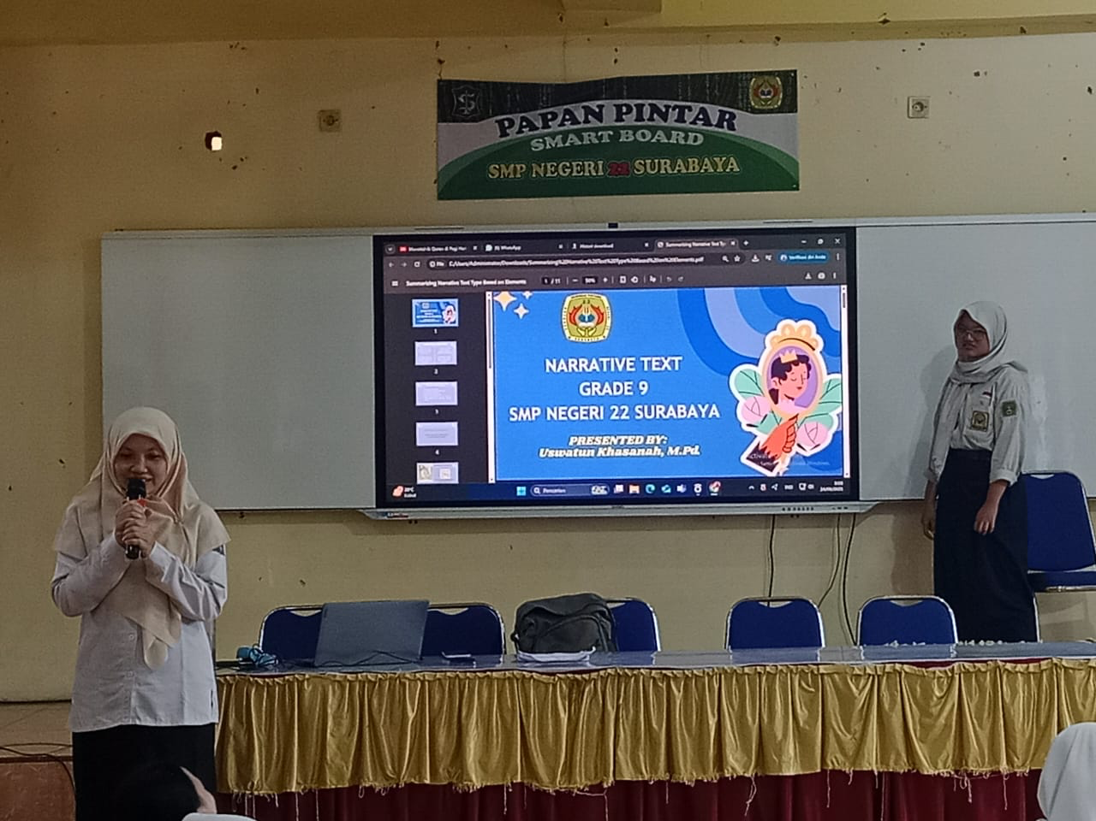
Figure 4.1 Media PowerPoint
Observation findings reveal that both teachers are using multimedia elements such as PowerPoint videos and online quizzes. The students are actively involved in doing worksheets and projects under the supervision of teachers. Classes concluded with learning activities involving Quizizz to keep learners engaged while inducing a friendly rivalry at the same time. Despite some students being less active, most of them show enthusiasm, indicating that pedagogical creativity is a key driving force for class participation and enthusiasm.
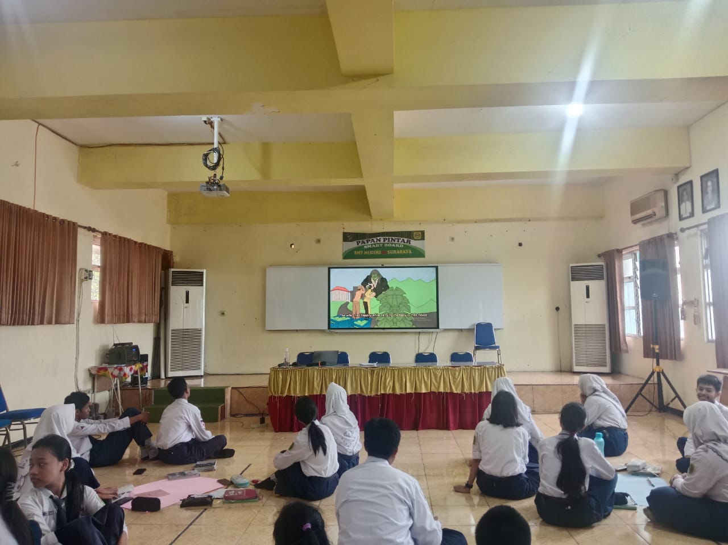
Figure 4.2 Video Online
The creativity exhibited by the teacher also manifested through assessment processes that valued flexibility and student-centred assessment. Ms. A explained that she relied on information from students provided by the guidance counsellor to develop differentiated assessment processes for her students when she said:
“I usually ask for data from the guidance counsellor first, as there are aptitude and cognitive tests for children. From there, I can see where the child's inclinations lie. In addition, I also observe them directly in class. When I give them assignments, they can choose the format themselves, whether it be drawings, videos, or presentations. This way, it suits their individual interests and talents. (Ms. A, T5).”
Her strategy reflects data informed creativity that acknowledges individual preferences. By allowing students to choose task formats the teacher supports autonomy and self-expression while keeping learning objectives measurable.
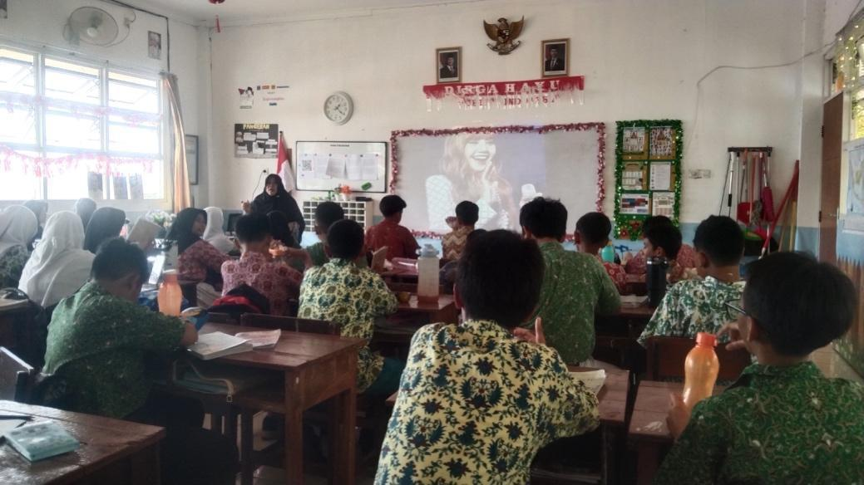
Figure 4.3 Video Online
Similarly, Ms B designed assessments that accommodated students’ interests and strengths. She explained:
“At the beginning, I map out their interests and talents, conducting a kind of light diagnostic test and asking them directly, ‘How would you like to do this?’ Whether it's audio, audiovisual, posters, or writing, it's up to them. The learning objectives remain the same, but the approach can be different according to the child's preferences. (Ms. A, T5).”
This shows how flexible assessment can be achieved while keeping a keen sense of academic rigor and at the same time encouraging students' empowerment through the provision of choice. It was noticed during class observation that the students worked with a lot of enthusiasm when given the choice of selecting their preferred form of expression which led to increased ownership of the projects. Teacher creativity with a view to encouraging inquiry and independent thinking was also manifest when Ms A mentioned the use of open-ended activities for encouraging exploration and questioning. She explained:
“I usually give open-ended assignments, such as making posters on Canva. From there, they have to find information themselves, discuss with their friends, and eventually ask questions and develop their own ideas. So, they don't just receive information from the teacher. (Ms. A, T3).”
This approach fosters curiosity and critical thinking skills by transforming passive receivers into active learners. Open-ended tasks are also useful in promoting collaborative and autonomous learning because the learners develop their understanding of a topic by discovering and exploring. According to Ms. B, there is a similar approach in project-based learning that connects research and technology integration. She said that:
“The endangered animals project is one example. They research animals, process information, choose appropriate visuals, and then give a presentation. For the narrative, they analyse the elements of the text and then compile a story map. In the future, I plan to combine Canva with Assembler Edu so that we can use augmented reality, allowing children to ‘enter’ the world of the story. (Ms. B, T6).”
Her statement indicates advanced creativity through the integration of technology to create more immersive learning experiences. By combining research activities with augmented reality Ms B aims to translate abstract understanding into interactive experiential learning.
Classroom observation showed that during such activities, discussions and question-answer sessions were commonly held by the students. In such cases, the teachers provided facilitation by giving guidance without refraining the learners from exploring their ideas themselves. This approach supported comprehension while encouraging collaboration and innovation as well. In these ways, teacher creativity served as a crucial driver of inquiry-based and meaningful English learning.
- The Challenges That Teachers Faced in Creative Learning Strategies in English Language Teaching
Through interviews with teachers and observations in some of their classes, some challenges were identified that constrained the optimum implementation of creative learning methods in English teaching in SMP Negeri 22 Surabaya. These findings can be summarized in three categories, which are challenges related to the teacher's internal capacity, students, and the availability of facilities in the institution. These are summarized in table 4.2 below.
Table 4.2 Challenges that Teachers encounter when applying Creative Strategies
Competency | Students | Facility
Preparing and implementing creative strategies | Wide differences in students’ English proficiency | Digital devices
Balancing curriculum requirements and creativity | Low focus among some male students sitting at the back | Unstable internet connection during lessons
Managing heterogeneous classes through differentiation | Varied student motivation in group projects | Limited learning resources besides projectors
Providing fair yet motivational assessment | Inclusive students requiring simplified materials | Incomplete use of creative applications due to device limits

Interview and observation data reveal that, in practice, teachers encountered a number of inhibiting factors to realize creative learning approaches in their English teaching. These limiting conditions were manifest in three interlinked spheres: namely, teacher competence, students, and facilities, each of which influenced the degree to which creativity in teaching could be successfully embodied in the classroom. This view is supported by Gulikers et al. (2004), who contend that problems in education are often created through an interaction between internal and external constraints, including teacher capacity, learner diversity, and environmental support, as encapsulated in Table 4.2.
The role of teacher creativity in creating interesting English classes cannot be underestimated but is made less feasible because of practical challenges that hinder complete implementation. The challenges that emerged after conducting the interviews on Ms A and Ms B and further complimented by observation were identified as the greatest four categories that affect them namely the lack of facilities, the curriculum and assessment structures that restrain teachers, the varying ability of students, and the time factor.
Mr. A pointed out that these children lack access to school facilities that could aid in the use of creative approaches in learning. According to Mr. B, “Many children in our school don’t have an adequate educational environment to support such approaches to learning.” Mr. B’s school has very basic school facilities. She stated:
“If the media is incomplete, we have to rack our brains. Sometimes we want to use digital media, but there are students who don't bring their cell phones or have used up their data allowance. So, like it or not, I have to provide manual alternatives, for example, drawing posters on paper, or if we play quizzes, I read the questions one by one. (Ms. A, T7).”
Her words suggest that inequalities in technology accessibility imply that the dual mode class needs to be created by the teacher through activities on the computer for those with access to technology in class and activities by hand for those without. This adaptive form of innovation promotes inclusivity but adds to the extra work. Ms B made similar sentiments regarding issues related to technological support. She stated:
“Thank God we have a projector, so we don't have to write long notes on the board anymore. But if we want to be more creative, for example, by having the children try AR or interactive videos, it can be difficult. Some children don't have adequate devices, or in the classroom, the internet connection is unstable. (Ms. B, T7).”
This implies that the facilities are not entirely available because projectors can support some multimedia functions but are not suitable for the requirements of innovative learning that may involve augmented reality or interaction. This may create a limitation to innovative plans by teachers due to an unstable internet connection and an imbalance of devices in use by some of the students.
The observation data indicated support for these findings with the evidence of teachers using projectors well in visual presentations, though students were inattentive, especially males sitting at the back of the classroom. The teachers attempted to engage them using humour and light interaction but seemed to have some students who looked disinterested despite the improvement in facilities. This indicated that merely improving the facilities may not contribute largely to participation if there is a discrepancy in students’ digital preparedness levels. Creativity in learning among teachers depends not only on technology but also on behaviour in the classroom.
Beyond infrastructure teachers also faced constraints from rigid curriculum structures and the dominance of standardized assessment practices. Ms A explained:
“The curriculum already has its own targets. So sometimes, if we want to explore further using creative methods, we run out of time. Moreover, there are demands from certain exams or assessments, so we still have to adjust. Creativity is allowed, but the curriculum objectives remain the benchmark. (Ms. A, T3).”
Her rationale highlights that in some cases, objectives in the curriculum may limit experimentation due to teachers being required to attain specific goals in predetermined time frames, thus leaving a shorter time for exploratory learning through projects or inquiry-based learning. A concern echoed in this theme is brought out by Ms B in stressing a contradiction between creative pedagogy and assessment with an examination orientation in mind when she said:
“When it comes to exams, the system is standardized. So, the children still have to be prepared for exam questions. Sometimes I feel that creative methods are not really accommodated in standard exams. So, in the end, we have to strike a balance between creative elements and drilling questions. (Ms. B, T8).”
Her words indicate a misfit between being creative and standardization. Being creative may be a means to develop high-order thinking although examination settings may promote these processes because being accurate may therefore stress a teacher to be both creative and standardized.
Another significant issue at stake concerns the diversity of the students’ capabilities and learning styles. As noted by Ms A, the students do not have the same level of English proficiency which makes it difficult to maintain a good balance in class. This was explained when she said:
“When there is a group presentation, the smart kids can speak fluently. But the kids with lower abilities usually just stay quiet. So, I have to arrange for the weaker kids to have easier parts. The important thing is that they remain involved and are not left out. (Ms. A, T7).”
This means that teachers should create differentiated activities that ensure that the marginalized group in terms of proficiency capabilities does not remain marginalized. Class size is, therefore, a challenge to delivering creative lessons.
Ms B also highlighted a similar problem of ensuring active participation of all learners. She said:
“Children are diverse. Some are very active, while others are passive. When given a project, the active ones immediately get to work, but the passive ones tend to give up. So I have to monitor them closely to ensure that every child has a responsibility. Otherwise, only a few will do the work. (Ms. B, T5).”
Her comment underlines the need for ongoing monitoring and group management. Teachers must plan the activity and also ensure equal participation which calls for sustained attention and flexibility in the classroom.
Classroom observations corroborated these accounts by showing that group tasks often produced uneven participation. Some students engaged actively in completing worksheets while others appeared indifferent or distracted. The teachers repeatedly circulated to monitor progress and prompt interaction yet equal participation remained difficult to achieve and this challenge required sustained patience and creative classroom management.
Time limitation also emerged as a critical barrier. Ms A emphasized that creative lessons often require substantially more time than conventional teaching. She noted:
“If you want to create creative learning, it takes a lot of time. Sometimes, before we finish, it's already time for the next lesson. So, there are ideas that are actually good, but we can't implement them because of time constraints. (Ms. A, T5).”
This means that a packed class schedule only allows less room for experimentation, reflection, and performance-based activities. Teachers often have to compromise by simplifying or omitting creative aspects in order for lesson goals to fit within a time constraint.
Ms B’s concern was echoed, and she added details to the apprehension regarding the school routine. She explained:
"Especially if the lesson is after the second break, there is MBG (Free Nutritious Meals). That takes up 20-30 minutes to tidy up after MBG and get the children ready again. So, the time that could have been used for creative activities is greatly reduced. (Ms. B, T7)."
Her statement illustrates how sometimes factors outside the control of the teachers could limit the amount of teaching time further. As creative tasks tend to involve long periods of work, teachers may be forced to cut short such activities due to daily routines and schedules.
Classroom observations certainly supported the view that the challenge of time management, in balancing explanation, group organization, and assessment, was often overwhelming for teachers. Several sessions seemed rushed, leaving little room for reflection or feedback. Within these constraints, the teachers still attempted to maintain a level of enthusiasm via short quizzes and brief discussions. The pattern here is indicative, again, of how constraints on creative teaching arise not from lack of intention but from systemic and contextual conditions with which teachers are constantly having to negotiate.
.
- Discussion
This paper will specifically deal with two key issues, which are the manifestation of creativity shown by teachers in their teaching of the English language in class and the challenges that they encounter in doing so. Therefore, a brief discussion of this first major finding follows. A further detailed discussion follows:
- The Creativity Teachers Perform in Teaching English
The implications from the findings suggest that creativity in English language teaching among teachers is realized through three aspects that can be categorized as encouragement, pedagogical competence, and assessment management. The aspect of encouragement is linked to teachers' ability to foster a positive environment that promotes student motivation and self-confidence and also provides a stimulus for participation and risk-taking experiences. Pedagogical competence is related to teachers' ability to deliver materials through innovative approaches that can encompass technology as well as different learning styles that can suit different levels of students’ ability. The aspect of assessment management is linked to creativity through flexible assessment that is appropriate according to students’ needs and ability levels. The overall implications of the findings suggest that creativity among teachers does not exist as a solitary trait but as a comprehensive pedagogical process that uses cognitive and affective aspects of a learning process to influence effective learning experiences.
While all teachers in this study demonstrate creativity across the three aspects identified, the extent to which their creativity is implemented depends on their pedagogical competence and, to some degree, situational factors. This suggests that creative teaching is not a fixed ability that remains constant, but an adaptive capacity shaped by pedagogical awareness and reflective responses to classroom realities. This aligns with Harmer (2007), who argues that pedagogical competence provides the essential foundation for creative teaching because it enables teachers to balance creativity with structure during instruction. In this study, such balance is understood as designing creative learning strategies that remain purposeful and aligned with lesson objectives, learners’ readiness, and classroom constraints. Creative activities may offer novelty and student engagement, but they need clear instructions, appropriate scaffolding, effective time management, and a consistent focus on language learning outcomes so that creativity supports learning rather than becoming a distraction. When teachers have strong pedagogical competence, they can translate creative ideas into suitable teaching activities that enhance engagement and comprehension and, ultimately, improve students’ learning performance.
For the first dimension of creativity on the educational front, the actualization of the aspect of creativity happens as a result of the capability of teachers to establish a psychologically safe and supportive learning environment that decreases anxiety and promotes participation. This corresponds perfectly with Mulyasa (2007) Self Esteem Approach that recognizes the establishment of students’ confidence as a psychological ingredient for successful surpassing. The study involved teachers who emphasized the aspect of motivation and encouragement that sustained the students’ attention and participation more often that confirms the component of affective reinforcement operating as a fundamental ingredient of the aspect of entrepreneurship or creativity. This aspect of motivation also transcends the component of words as teachers prepare tasks that enable students to achieve minuscule successes that boost the component of self-efficacy and interest accordingly. For the aspect of entrepreneurship/creativity concerning encouragement, it functions rather than the mere component of emotions. It is a deliberate teaching practice that draws on psychological sensitiveness and awareness of social interactions. This aspect indicates that entrepreneurship/creativity on the teaching front also operates on the affective component where the instructor controls the components of emotion, motivation, and the social aspect accordingly.
The second dimension of pedagogical competence emerges as the most complex and important dimension of teacher creativity because it encompasses the implementation and adaptation of learning strategies in planning. Creativity in pedagogy implies that teachers must be able to transform the curriculum requirements of education into interesting activities that fulfil the instructional requirements of education. According to Harmer, this dimension of pedagogy makes an important contribution to teacher creativity because it makes it possible to accommodate content, methods, and learner diversity in an instructional design. The current study validates this perspective because it has been found that teachers who possessed greater pedagogical competencies were found to use technology-based media projects and differentiated instruction to cater to different styles of learning to a greater extent. Such aspects make it apparent that the art of teacher creativity lies in professional expertise that emanates from systematic planning in education, and not in the spontaneous acquisition of skills in an unmethodical manner.
Harmer’s account of this aspect of creativity suggests that pedagogic competence serves as a precursor for creative teaching since it enables teachers to synthesize their methodological knowledge with contextual awareness. This result would suggest that creativity is impossible to divorce from pedagogic literacy and continuous professional development since the practitioner designs creative lessons more intuitively when aware of the principles that drive instructional innovation. The research accordingly concludes that sustained teacher creativity relies upon institutional support such as training in instructional design, technology integration, and reflective practice. In this perspective, creativity becomes a professional entity that evolves through ongoing learning, experimentation, and assessment rather than an individual talent. Such findings also support the assertion that creative teachers work not only as imaginative practitioners but as systematic thinkers who integrate pedagogical acumen, planning skills, and reflective assessment within the teaching process.
The third dimension of assessment management highlights the application of creativity in the assessment of learning outcomes. In this regard, instead of relying on the conventional approaches of evaluation that focus on standardized tests, the application of creativity in assessment entails the use of performance-based evaluation approaches that focus on the diverse abilities of the learners. Such an occurrence is justified by Umam et al., who state that the application of creativity in evaluation is characteristic of the adapting behaviour of teachers when considering the outcomes of learning. The data has the potential to show that teachers view assessment not only as measurement for the purpose of judgment. Assessing in the class is now interactive as well as diagnostic. Such is attributable to the aspect that the assessment assists in monitoring progress. Additionally, assessment is diagnostic due to the aspect that learners need to work on aspects that require improvement.
Furthermore, the findings also point out that creative teaching requires intensive preparation time and cognitive work because of the careful planning involved in developing interactive multimedia, differentiated activities, and authentic assessments, which need considerable time as well as cognitive effort, most patently under time-constrained instructional settings. Nonetheless, under these challenging conditions that might constrain creativity to some degree, teachers who persistently execute creative teaching show remarkable commitment to their professional work. Based on these findings, creativity in both pedagogies and professionalism is therefore characterized by perseverance and marked by a reflective improvement trajectory. Finally, these findings also suggest that while creative teaching requires resource investment for creative activities to take place, creativity at work requires an organizational culture of innovation for which professional commitment is essential to support creative work at work either inside or outside of classrooms.
Overall, this study concludes that creativity on the part of the teacher in English language teaching draws together three major elements with each element playing its own role since encouragement is important for the development of emotional intelligence, pedagogical competence helps with the provision of methodologies, and management of assessment helps with achieving authentic learning results. Creativity and English language teaching always continue to be sensitive with respect to time and workloads. Creativity on the part of the English language teachers should always be perceived not only from the perspective of innovation but also with respect to its continuous nature and an ongoing process that requires continuous developmental change.
- The Challenges That Teachers Faced in Creative Learning Strategies in English Language Teaching
The issues encountered by teachers in executive learning styles for effective English language learning remain a top concern for modern educators. This is due to the universally accepted importance of creativity as a driving force that supports productive and engaging learning processes and as such, according to Ryhammer and Brolin, it builds the problem-solving skills and adaptability of learners who require these skills in 21st-century learning. However, what the study has established and confirmed has been faced by teachers when trying to link creativity and practice. These challenges fall into four main aspects: insufficient infrastructure resources, the rigidity of the curriculum and evaluation systems, the mixed ability learning of students, and insufficient instructional time.
A challenge that is perhaps more perennial in nature is the quality of facilities and technological provisions that facilitate creative learning tasks. Though in most institutions the basic learning facilities like projectors or whiteboards are in place, unreliable internet availability, a lack of students’ engagement with technological devices, and support could have an impact on the teacher’s ability to apply creative learning strategies in the classroom environment. Such technological strategies involving gamification, blended learning, or the use of interactive media such as Quizizz, Kahoot, Padlet, or Canva are highly reliant on an institution’s preparedness and provision of technological support conditions. Gulikers et al. (2004), have pointed out that one of the sources of difficulties in pedagogical innovation is a lack of support infrastructure. Similarly, Umam et al., have explored in their study that a supportive technological environment in institutions facilitates creative learning strategies to work better in the classroom environment. The results, thus, have reiterated that an increase in teacher creativity continues to remain a function of the educational environment in which these teachers work.
The demands of the curriculum and the assessments also constrain the creativity of the teachers, who are working to achieve the competency levels specified in the national standards within set deadlines. This sometimes causes the teachers to lean more towards specific goals of learning rather than learning processes in art education, explains Gregerson (2007), where a flexible system of creativity allows for more enhanced growth in creativity whereas a reliance on quantitative achievement hinders a teacher’s creativity. Ma also asserts that a teacher with strong creativity self-efficacy could also face cognitive dissonance when there are contradictions in the curriculum to innovation in teaching. Therefore, teachers tend to combine creative pursuits with exam preparation in an effort to promote a composite approach to learning which may discourage creativity in learning but also could have adverse effects on academic achievement
Student diversity poses an enormous teaching challenge that examines the teachers’ ability to adapt since the student abilities range greatly from very fluent participants to reluctant participants across the same English class. To cater for student diversity, innovation and differentiated instruction are called for all the time, but operational constraints limit teachers from involving all students proportionately. Mulyasa (2007) Multiple Talent Approach suggests that each student has his or her own cognitive and affective talents that necessitate varied learning processes. However, Umam et al find that despite teachers having the ability to use creativity effectively in the classroom, unmotivated students will always be there due to variations in prior knowledge and rates of learning despite the creativity exhibited by the teachers.
The time limit is also a structural barrier that stifles creative teaching because some of the approaches like the project-based learning approach or inquiry-based instruction and gamification require a longer preparation time that cannot be contained within the typical class time schedule. The time teachers require is also needed for the preparation of materials and other administrative tasks that do not allow time for the development of more reflective, primarily pedagogically focused approaches. According to Gregerson (2007), time flexibility is important during the development of a meaningful and well-structured teaching process that promotes innovation because Zhi and Wang (2023) established that a shortened time schedule affects the feasibility of implementation according to the findings presented here. There is also termination of the application of the approaches and the implementation of the lecture method that is more time and cost efficient.
Institutional support is also important for teachers to continue with innovative teaching practices since sometimes teachers depend on measures and programs put up by institutions. While most institutions may offer basic teaching facilities to teachers, teachers in this research express a lack of staff development opportunities that concentrate on innovative teaching approaches. According to Richards, when institutions offer encouragement and training for creativity in language learning programs, creativity can easily be achieved since teachers may not venture into new approaches as they expect disapproval from administrators and may fail in their approaches. Findings from Zhi and Wang (2023) indicate that when institutions offer teachers autonomy through empathy and when institutions offer a culture of innovation and constant improvement, creativity increases since teachers may not venture into new approaches as they may fail.
On a holistic analysis, it appears that the issues that teachers face in applying creative approaches to learning are complex and interlinked in various ways. These issues range from the lack of resources in class to issues of inflexibility in structure, diversity in students, compression of time, and institutional resistance that constricts the scope of applying these approaches. This reflects an apparent contradiction in that Creativity is envisioned as a virtue of good teaching, but its full scope cannot be applied in that context. According to Ryhammer and Brolin, Creativity should not exist in a vacuum because it needs an enabling environment that allows it to be open, experimental, and reflective. Moving the agenda of Creativity in English Language Teaching would require systemic changes that would ensure an enabling environment of policy frameworks that would ensure equitable resource allocation to close the gap between Creativity and Reality.

CHAPTER V
CONCLUSION AND SUGGESTIONS

This chapter presents conclusions drawn from the research results and discussions in the preceding chapters. It also offers recommendations for teachers, students and future researchers as follow up to this study on teacher creativity in English language learning and the challenges teachers encounter when implementing creative strategies.

- Conclusion
Based on the results of research, interviews, observations, and analysis of previous theories and studies, the following conclusions can be drawn:
      - Teachers showed their creativity in the English learning process using strategic student-centred approaches to create engaging, meaningful, and enjoyable learning experiences while boosting their confidence and participation. Teachers showed flexibility in task assignment according to students’ confidence by assigning fewer challenging tasks to more reserved students while assigning challenging activities to students who exhibited more confidence. Creativity is also seen through group organization since teachers tackled tasks in a manner that fostered balanced participation and collaboration by all members of the group. They also employed electronic learning resources such as Quizizz Kahoot Canva Padlet PowerPoint to boost participation and linkages with learners’ daily activities and experiences. The teachers also conducted project-based learning problem-solving exercises and open-ended inquiry questions involving activities such as poster-making and story mapping. Using these approaches, creativity for teachers ended up being an enabler of not only knowledge mastery but also of motivating learners, confidence-building, collaboration, and idea creativity.
      - The teachers encountered difficulties in delivering creativity to their students. Many resources such as lack of facilities, uneven accessibility of devices to students, and unreliable internet connectivity limited their resources to a certain extent to which teachers had to find alternatives through manual work to compensate for these differences. The teachers had limited creativity to offer their students with tight curriculum activities that limit their time to offer creativity to their students through innovative approaches. Differences in students' ability levels also created difficulties for teachers to maintain equity to include all students to participate with balanced efficiency despite varying ability levels of students. The time constraint also acted as a barrier to offer project-based learning since electronic media takes time to plan while class time remained inadequate despite limited time to their teaching sessions at schools.

- Suggestions
Based on the results of the study, the author provides several suggestions for teachers, students, and future researchers, as follows:
- For Teachers
The results provide specific manifestations of creativity which the teachers have in practice in classrooms such as using open-ended tasks, role allocation according to levels of confidence, the allocation of learning tasks in a differentiated manner, learning tasks using computers, and inquiry-based learning tasks. The results may help teachers become more familiar with the potential of specific practices in yielding maximum positive impact on students in particular with respect to confidence building, collaboration, and engagement. The teachers are encouraged to apply the results to modify the identified issues such as the lack of time in planning in an adaptive manner so that alternative strategies may also be employed in light of the specific needs of the classroom environments that are dealt with by the teachers.
- For Students
The results suggest that students are positively responsive to learning designs that are interactive, collaborative, and technology-rich. The students are, therefore, encouraged to take an active role in such learning creative experiences by sharing ideas, being consistent in collaborative learning tasks, and making use of technology offered in learning by teachers. The results also suggest that students can increase confidence levels and enhance understanding by taking a more open approach in creative learning experiences.
- For Future Researchers
Future studies can also examine creativity in teaching by applying different analytical perspectives such as analysing the decision-making processes involved in the creative decisions made by teachers or by analysing the relationship between creativity and the professional identity of teaching. The study can also be developed in different methodological perspectives including conducting longitudinal studies on the development and progress of creativity in teaching.

REFERENCES

Abdullah, N., Mustafa, Z., Hamzah, M., Dawi, A. H., Mustafa, M. C., Halim, L., Saleh, S., & Abdul Khalil, C. S. H. A. C. (2021). Primary School Science Teachers’ Creativity and Practice in Malaysia. International Journal of Learning, Teaching and Educational Research, 20(7), 346–364. https://doi.org/10.26803/ijlter.20.7.19
Abraham, A. (2024). The Creative Brain: Myths and Truths. MIT Press.
Adeniyi, I. S., Al Hamad, N. M., Adewusi, O. E., Unachukwu, C. C., Osawaru, B., Onyebuchi, C. N., Omolawal, S. A., Aliu, A. O., & David, I. O. (2024). Educational Reforms and Their Impact on Student Performance: A Review in African Countries. World Journal of Advanced Research and Reviews, 21(2), 750–762. https://doi.org/10.30574/wjarr.2024.21.2.0490
Agustina, E. T., Wahyudin, A. Y., & Pratiwi, A. A. (2021). The Students’ Motivation and Academic Achievement at Tertiary Level: A Correlational Study. Journal of Arts and Education, 1(1), 29–38.
Alghamdi, M. S., & Khadawardi, H. A. (2024). Investigating the Impact of Teacher Enthusiasm on Engagement Among Saudi First-Year EFL Students. International Journal of English Language Education, 12(2), 86. https://doi.org/10.5296/ijele.v12i2.22241
Ariyanti, N. D. S., & Maryanti, R. (2021). Developing the Creativity of Elementary School Students in Cimahi, Indonesia through Online Learning Media during the Covid-19 Pandemic. Indonesian Journal of Teaching in Science, 2(1), 7–16.
Arooj, T., Parveen, S., Iqbal, M., & Kamran, M. (2021). Proposing Creativity Inclusion in the Primary Education of Pakistan: Analysis of Educational Policy Documents and Curricula of Multiple Countries to Draw the Framework. Turkish Online Journal of Qualitative Inquiry, 12(9), 3088–3095.
Assulaimani, T. (2021). The effect of Classroom Management in Oral Communication and Willingness to Communicate: A Case Study of Saudi Learners of English as Foreign Language. Applied Linguistics Research Journal. https://doi.org/10.14744/alrj.2021.24008
Azizah, A., Rizal, R., Yudtika, A. P., & Sitepu, M. S. (2022). Teacher Creativity Relationship with Interest Students Learning at SD Inpres Lolu During Pandemic. Nazhruna: Jurnal Pendidikan Islam, 5(2), 777–786. https://doi.org/10.31538/nzh.v5i2.2232
Balaskas, S., Zotos, C., Koutroumani, M., & Rigou, M. (2023). Effectiveness of GBL in the Engagement, Motivation, and Satisfaction of 6th Grade Pupils: A Kahoot! Approach. Education Sciences, 13(12), 1214. https://doi.org/10.3390/educsci13121214
Beer, Z. De, & Barnard, E. (2021). Grade R Teachers’ Experiences of Implementing Physical Education. African Journal for Physical Activity and Health Sciences (AJPHES), 27(2), 248–264.
Caulfield, J. (2023). How to Design and Teach a Hybrid Course: Achieving Student-Centered Learning through Blended Classroom, Online and Experiential Activities. Taylor & Francis.
Chen, H.-H., & Yuan, Y.-H. (2021). The Study of the Relationships of Teacher’s Creative Teaching, Imagination, and Principal’s Visionary Leadership. Sage Open, 11(3). https://doi.org/10.1177/21582440211029932
Cremin, T. (2022). Teaching English Creatively. In Teaching English Creatively. Routledge.
Creswell, J. W. (2012). Research Design Pendekatan Kualitatif, Kuantitatif, dan Mixed. Yogyakarta: Pustaka Pelajar.
Darling-Hammond, L. (2021). Defining Teaching Quality around the World. European Journal of Teacher Education, 44(3), 295–308. https://doi.org/10.1080/02619768.2021.1919080
de Oliveira, E. R., & Pasqualotti, A. (2023). Educational Process in E-Learning Activity for Elderly People: A Systematic Review. Interactive Learning Environments, 1–16. https://doi.org/10.1080/10494820.2023.2184391
Dollah, S., Sehuddin, M. F., & Sakkir, G. (2021). Motivating EFL Learners to Write Using Padlet Application. ELT Worldwide, 8(2), 240–254.
Fadzil, A. H. P., Maat, S. M., & Mahmud, M. S. (2022). A Rasch Model Analysis of the TPACK Instrument in the Creative Teaching of Primary Mathematics Teachers. Cypriot Journal of Educational Sciences, 17(11), 4259–4274.
Ferdiansyah Doni, & Kaltsum, H. U. (2023). Teacher’s Strategy in Growing Student Creativity through the Pancasila Student Profile Strengthening Project. Jurnal Ilmiah Sekolah Dasar, 7(1), 46–54. https://doi.org/10.23887/jisd.v7i1.55198
Ferris, D. R., & Hedgcock, J. S. (2023). Teaching L2 Composition. New York: Routledge. https://doi.org/10.4324/9781003004943
Gregersen, T. S. (2007). Language learning beyond words: Incorporating body language into classroom activities. Reflections on English language teaching, 6(1), 51-64.
Gulikers, J. T. M., Bastiaens, T. J., & Kirschner, P. A. (2004). A five-dimensional framework for authentic assessment. Educational Technology Research and Development, 52(3), 67–86.
Hamilton, D., McKechnie, J., Edgerton, E., & Wilson, C. (2021). Immersive Virtual Reality as a Pedagogical Tool in Education: A Systematic Literature Review of Quantitative Learning Outcomes and Experimental Design. Journal of Computers in Education, 8, 1–32.
Hasanuddin, U. F., & Malihah, N. (2023). Revolutionizing Education: The Islamic Perspective on Merdeka Belajar Curriculum and Its Successful Implementation at a Middle School in East Kalimantan. AL-ISHLAH: Jurnal Pendidikan, 15(4), 4568–4577.
Hestika, Qalbi, N., & Baso, F. A. (2021). The Effect of Teachers’ Creativity on Students Interest in Learning English in the Second Grade SMP Negeri 2 Tinambung. Journal of Language Testing and Assessment, 1(1), 21–29. https://doi.org/10.56983/jlta.v1i1.175
Hidayat, D. N., & Mason, J. (2023). Factors Impacting English Teachers’ Creativity in Teaching English as a Foreign Language in Indonesia. Studies in English Language and Education, 10(1), 155–173.
Hill, T. G., Coughlan, E. C., & Mackinnon, S. P. (2023). Crafting Happiness from Everyday Life: Personality, Personal Projects, Basic Psychological Need Satisfaction, and Well-Being. International Journal of Personality Psychology, 9, 47–60. https://doi.org/10.21827/ijpp.9.39811
Huang, X., Sun, M., & Wang, D. (2022). Work Harder and Smarter: The Critical Role of Teachers’ Job Crafting in Promoting Teaching for Creativity. Teaching and Teacher Education, 116, 103758. https://doi.org/10.1016/j.tate.2022.103758
Iryana, P. A. R. (2021). Analisis Penanganan Stress dan Kelelahan Kerja terhadap Prestasi Kerja Perawat Rumah Sakit Umum Sidoarjo. Sasanti Journal Of Economic and Business, 2(3), 26–31.
Iskandar, R., & Zulela, M. S. (2021). Professionality Analysis of Basic Education Teachers as Agents to Improve Creativity in Digital Era. Jurnal Ilmiah Sekolah Dasar, 5(1), 16–24.
Liu, C.-Y., Lin, W.-W., & Wu, C.-J. (2022). Understanding the Properties and Processes of a Creative Teacher Team. International Journal of Educational Research, 111, 101909. https://doi.org/10.1016/j.ijer.2021.101909
Ma, Y. (2022). The Effect of Teachers’ Self-Efficacy and Creativity on English as a Foreign Language Learners’ Academic Achievement. Frontiers in Psychology, 13. https://doi.org/10.3389/fpsyg.2022.872147
Maksimoski, A. N., Stevenson, S. A., Polzin, B. J., Zhao, C., Luebke, E. M., & Riters, L. V. (2023). The Motivation to Flock Correlates with Vocal-Social Behaviors and Dopamine-Related Gene Expression in Male European Starlings. Hormones and Behavior, 153, 105374. https://doi.org/10.1016/j.yhbeh.2023.105374
Manurung, A., Sitepu, F. J., Purba, R. M., Hutahaean, P. M., Herman, H., & Panjaitan, M. B. (2023). The Role of Counseling Guidance to Increase Students’ Motivation and Learning Activities at Grade VI of SDN 091263. Jurnal Scientia, 12(01), 326–329.
Mattarima, S. M. U., Afifi, N., & Qamaria, R. S. (2022). English Study Club: How Students’ Mental Attributes Reflect Their MotivationEnglish Study Club: How Students’ Mental Attributes Reflect Their Motivation. Celtic: A Journal of Culture, English Language Teaching, Literature and Linguistics, 9(1), 120–134.
Meitiyani, Elvianasti, M., & Dharma, A. P. (2021). Correlation Between Students Creative Thinking Ability in Solving Environmental Problem with Achievement of Environmental Education. https://doi.org/10.2991/assehr.k.210430.042
Membrive, A., Silva, N., Rochera, M. J., & Merino, I. (2022). Advancing the Conceptualization of Learning Trajectories: A Review of Learning across Contexts. Learning, Culture and Social Interaction, 37, 100658. https://doi.org/10.1016/j.lcsi.2022.100658
Mesra, P., & Kuntarto, E. (2021). Faktor–Faktor yang Mempengaruhi Minat Belajar Siswa di Masa Pandemi. Jurnal Ilmiah Wahana Pendidikan, 7(3), 177–183.
Moleong, L. J. (2019). Metodologi Penelitian Kualitatif. Bandung: Remaja Rosdakarya.
Moseikina, M., Toktamysov, S., & Danshina, S. (2022). Modern Technologies and Gamification in Historical Education. Simulation & Gaming, 53(2), 135–156. https://doi.org/10.1177/10468781221075965
Muhajir, M., Kholis, N., & Syahid, A. (2024). Enhancing Student Comfort in Lampung Islamic Boarding Schools: Communication and Psychological Support. Ath-Thariq: Jurnal Dakwah Dan Komunikasi, 8(1), 71–80.
Mulyasa, E. (2007). Menjadi guru profesional: Menciptakan pembelajaran kreatif dan menyenangkan. Rosdakarya.
Murdiana, M., Jumri, R., & Damara, B. E. P. (2020). Pengembangan Kreativitas Guru dalam Pembelajaran Matematika. Jurnal Pendidikan Matematika Raflesia, 5(2), 152-160.
Nurdiyanto, N., Musyfiq, A., Karman, K., & Nursobah, A. (2024). Independent Curriculum Development Strategy in Islamic Religious Education: Conceptual Studies of Building Character and Nationality. Tarbiyah : Jurnal Ilmiah Kependidikan, 13(1), 65–80. https://doi.org/10.18592/tarbiyah.v13i1.12072
Nuriddinovna, B. M. (2025). New Methods Of Teaching English. International Conference On Modern Development Of Pedagogy And LinguisticS, 2(2), 42–47.
Pertiwi, S. A. (2023). Pengenalan Dasar-Dasar Bahasa Inggris pada Tingkat Sekolah Dasar di Merauke. Jurnal Pengabdian Masyarakat Dan Riset Pendidikan, 2(1), 76–79. https://doi.org/10.31004/jerkin.v2i1.121
Pohan, Z. A., Siregar, M. F. Z., & Sembiring, N. S. K. B. (2022). Strategi Masyarakat Menghadapi Perilaku Buruk Remaja. Khazanah: Journal of Islamic Studies, 1(1), 1–15.
Procel, G. J. O., Medina, M. L. F., Sotomayor, D. J., & Sanchez, M. A. (2024). Using Technology in English Teaching. Journal of Environmental Research and Public Health, 17(9).
Rahman, M. S., Herman, H., Iqbal, M., & Renaldi, S. (2021). Meningkatkan Kemampuan Pemahaman Materi Simple Present Tense Menggunakan Teknik Pengajaran Bahasa Inggris Grammar Translation Method pada Mahasiswa Anggota Language Club Stai Rakha Amuntai. UrbanGreen Conference Proceeding Library, 123–128.
Rapik, M. (2022). Kreativitas Guru dalam Mengolah Media Pembelajaran Daring. Journal of Instructional and Development Researches, 2(4), 146–152. https://doi.org/10.53621/jider.v2i4.104
Reilly, R. C., Lilly, F., Bramwell, G., & Kronish, N. (2011). A Synthesis of Research Concerning Creative Teachers in a Canadian Context. Teaching and Teacher Education, 27(3), 533–542. https://doi.org/10.1016/j.tate.2010.10.007
Renawi, A., Alnajjar, F., Parambil, M., Trabelsi, Z., Gochoo, M., Khalid, S., & Mubin, O. (2022). A Simplified Real-Time Camera-Based Attention Assessment System for Classrooms: Pilot Study. Education and Information Technologies, 27, 1–18.
Revenko, I., Sosnova, M., Kolodina, L., Hlianenko, K., & Vlasenko, R. (2024). The Exploration of Pedagogical Approaches and Methods That Are Designed to Stimulate the Creative Thinking of Students. Brazilian Journal of Education, Technology and Society (BRAJETS), 137–146.
Sarah, C., Karma, I. N., & Rosyidah, A. N. K. (2021). Identifikasi Faktor yang Mempengaruhi Minat Belajar Siswa pada Mata Pelajaran Matematika di Kelas V Gugus III Cakranegara. Progres Pendidikan, 2(1), 13–19.
Shermukhammadov, B. (2022). Creativity of a Teacher in an Innovative Educational Environment. Journal of Higher Education Theory and Practice, 22(12). https://doi.org/10.33423/jhetp.v22i12.5468
Starko, A. J. (2021). Creativity in the Classroom. New York: Routledge. https://doi.org/10.4324/9781003105640
Sternberg, R. J., Kaufman, J. C., & Karami, S. (2023). Intelligence, Creativity, and Wisdom: Exploring Their Connections and Distinctions. Springer Nature.
Sugiyono. (2018). Metode Penelitian Kuantitatif, Kualitatif, dan R&D. Bandung: Alfabeta.
Sugiyono. (2019). Metode Penelitian Pendidikan Pendekatan Kuantitatif, Kualitatif, dan R&D. Bandung: Alfabeta.
Suswandari, M. (2022). The Role of Parents in Learning at Home during the Covid-19 Pandemic. Al-Ishlah: Jurnal Pendidikan, 14(2), 2421–2428.
Umam, C., Aini, N., & Herdina, G. G. H. (2023). How Professional English Teachers Motivate Their Students: A Multiple Case Study. Proceeding International Conference on Religion, Science and Education, 295–307.
Wijaya, H., Darmawan, I. P. A., Setiana, S. C., Helaluddin, H., & Weismann, I. T. J. (2021). Active Reconnecting Learning Strategies to Increase Student Interest and Active Learning. Indonesian Journal of Instructional Media and Model, 3(1), 26. https://doi.org/10.32585/ijimm.v3i1.1290
Wisnu, H., Islam, B., Hidayatullah, M., & Jaelani, S. R. (2023). Teachers’ Creativity in Improving Students’ Interest in Learning English. Pendekar: Jurnal Pendidikan Berkarakter, 1(4), 367–376.
Zhi, R., & Wang, Y. (2023). English as a Foreign Language Teachers’ Professional Success, Loving Pedagogy and Creativity: A Structural Equation Modeling Approach. Thinking Skills and Creativity, 49, 101370. https://doi.org/10.1016/j.tsc.2023.101370
Žydžiūnaitė, V., & Arce, A. (2021). Being An Innovative and Creative Teacher: Passion-Driven Professional Duty. Creativity Studies, 14(1), 125–144. https://doi.org/10.3846/cs.2021.14087

APPENDICES

Appendix 1. Instrument Guideline

Instruments Guideline
- Sudah berapa lama Ibu mengajar bahasa Inggris? Bapak/Ibu mengajar bahasa di kelas berapa?
- Menurut Ibu kreativitas itu seperti apa?
- Dapatkah Ibu menjelaskan pelatihan atau pengembangan profesional apa saja yang pernah Ibu ikuti yang mendukung penggunaan kreativitas dalam pengajaran?
- Menurut Ibu, pembelajaran yang kreatif itu seperti apa ya?

No | Aspects Being Studied | Dimension | Questions | Theory
1. | The activities that teachers do in learning English.  (RQ1, RO1) | Self-Esteem Approach | - How do you build students’ confidence in learning English?  - In what ways does your creativity help students feel more motivated and valued during English lessons? | Creativity Theory (Mulyasa, 2007)
1. |  | Creative Approach | - What specific creative strategies do you usually use when teaching English?  - Can you share an example of a creative activity (e.g., role play, games, brainstorming) that successfully engaged your students? | Creativity Theory (Mulyasa, 2007)
1. |  | Multiple Talent Approach | - How do you adapt your teaching methods to accommodate students’ different talents and learning styles?  - Can you describe a creative activity that allowed students with diverse abilities to participate actively? | Creativity Theory (Mulyasa, 2007)
1. |  | Inquiry Approach | - How do you encourage students to ask questions and explore ideas creatively in English learning?  - Can you give an example of an inquiry-based activity that worked well in your class? | Creativity Theory (Mulyasa, 2007)
2. | The challenges that teachers have in creative learning strategies in English language teaching.  (RQ2, RO2) | Lack of Resources and Infrastructure | - How do limited resources (e.g., technology, teaching materials) affect your creativity in teaching English?  - Can you share an experience where a lack of facilities made it difficult to apply creative methods? | Challenges Creativity (Gulikers et al., 2004)
2. |  | Curriculum and Assessment Constraints | - How do curriculum requirements or standardized tests affect your freedom to use creative strategies?  - Do you feel that the current assessment system supports or limits creativity in English teaching? | Challenges Creativity (Gulikers et al., 2004)
2. |  | Diverse Student Needs | - How do you address the challenge of different abilities and learning styles when applying creative strategies?  - Can you give an example of a creative activity that worked for both advanced and struggling students? | Challenges Creativity (Gulikers et al., 2004)
2. |  | Time Constraints | - How does limited time in class affect your ability to plan and implement creative teaching methods?  - Do you sometimes choose traditional methods because they are more efficient than creative ones? | Challenges Creativity (Gulikers et al., 2004)

Appendix 2. Observation Guideline

Observation Guideline
No | Observed Aspects | Indicators | Data Source
1. | The creativity that teachers do in enhancing students’ interest in learning English.  (RQ1, RO1) | - Types of creative activities or methods used by teachers to increase student interest.  - Frequency of creative strategies applied in lessons.  - Teacher's ability to adapt and vary teaching to engage students. | Classroom observation
2. | The challenges that teachers have in implementing creative learning strategies in English language teaching.  (RQ2, RO2) | - Types of challenges faced during creative learning implementation.  - Frequency and impact of resource or time limitations.  - Teacher responses or strategies to overcome challenges.  - Support from school or institution in applying creative strategies. | Classroom observation

Option 1
- When selecting creative teaching media or methods, what patterns or preferences have you noticed regarding student response and effectiveness?
- Could you describe the types of creative activities or strategies you often use, and why you think they work well in your classroom?
- When some students grasp the material faster than others, how do you adjust the learning activities?
- Can you share an experience when a method did not connect with some students and how you addressed it?

Option 2
- What types of creative media do you usually use in your English lessons according to the curriculum?
- In your experience, how do these media support students with different learning needs?
- How do you adjust your teaching methods when using creative media to meet the needs of students with varying proficiency levels and learning preferences?
- From your observations, how do students usually respond or engage with lessons that include creative media?
- What difficulties have you encountered when using creative media in the classroom?
- How do you typically overcome technical issues or resource limitations when implementing creative media?
- Could you describe any challenges you’ve faced in aligning creative media content with students’ proficiency levels and curriculum goals?

Appendix 3. Result of The Data Collection

Participant 1
Name : Ms. A
Gender : Female

No |  | Transcribe
1 | Interviewer | Assalamuaikum, selamat pagi Miss. Pada wawancara hari ini saya akan memberikan pertanyaan mengenai kreativitas guru dan tantangan guru yang dihadapi selama proses pembelajaran di kelas.  Sebelumnya, pertanyaan pada wawancara ini bersifat semi-stucture ya Miss. Pertama-tama saya akan memberikan pertanyaan umum terlebih dahulu dan berlanjut ke pertanyaan utama serta pendukung.
2 | Participate | Baik, mbak. Silahkan dimulai dari pertanyaan umum dahulu.
3 | Interviewer | Baik, Miss. Sudah berapa lama Miss A mengajar mata pelajaran bahasa inggris dan di kelas berapa saja Miss mengajar mata Pelajaran tersebut?
4 | Participate | Saya sudah mengajar mata pelajaran bahasa inggris sekitar 12 tahun mbak dari beberapa sekolah. Untuk kelas yang saya handle meliputi kelas 8 dan 9 tapi lebih dominan di kelas 8.  Selain bahasa inggris, saya juga handle mata pelajaran bahasa indonesia, tapi hanya satu kelas saja mbak karena memang ada sedikit kendala pada mata pelajaran tersebut. Akan tetapi, tetap saya lebih berfokus pada mata pelajaran bahasa inggris.
5 | Interviewer | Begitu ya Miss. Menurut Miss A, kreativitas itu didefinisikan seperti apa dan pembelajaran kreatif?
6 | Participate | Kreativitas itu adalah suatu hal yang muncul dari seorang guru, seorang pendidik untuk membuat suatu aktivitas itu lebih bervariasi, lebih berwarna-warni untuk kegiatannya.  Dalam segi aktivitas, kemudian media ajar. Jadi kreativitas itu bermacam-macam, kreativitas dalam melaksanakan pembelajaran, dalam proses pembelajaran itu sendiri, dari mulai pembelajaran awal, kemudian pembelajaran inti, dan pembelajaran penutup di akhir.  Jadi, kreativitas itu harus dimiliki oleh seorang guru untuk membuat kelas itu lebih hidup, lebih berwarna, tidak monoton dan bisa menimbulkan juga kreativitas siswa untuk mengikuti pembelajaran pada hari itu.
7 | Interviewer | Baik Miss. Apakah di SMP ini juga ada pelatihan guru dalam menumbuhkan kreativitas tersebut?
8 | Participate | Ada pelatihan, sejenis pelatihan. Kalau di SMP sendiri ada pelatihan, tapi secara umum. Jadi kalau untuk guru itu biasanya guru yang harus mencari sendiri, di samping dia itu mendapatkan ilmu itu dari dulu waktu kuliah atau waktu dia mengikuti pelatihan di MPMP, atau pelatihan di luar, misalnya seminar atau apa. Tapi untuk dari sekolah itu sendiri, sekolah itu mengimbau guru untuk mengikuti pelatihan secara mandiri di ruang GTK sekarang namanya, kalau dulu di BMM.  Sekarang namanya ruang GTK. Di sana guru bisa mengikuti berbagai macam pelatihan, termasuk mungkin salah satunya adalah pelatihan bagaimana menjadi guru yang kreatif. Pelatihan itu biasanya mempelajari modul-modul secara online di LMS ruang GTK itu yang difasilitasi oleh Kemendikdasman dengan melalui akun belajar ID yang dimiliki oleh setiap guru. Jadi dengan akun tersebut, guru bisa mengakses ruang GTK. Di sana ada pelatihan mandiri, mempelajari modul-modul, mempelajari video. Jadi guru-guru di seluruh Indonesia itu diminta untuk belajar secara mandiri oleh Komendikdasman tentang materi-materi yang mendukung kreativitas guru, bagaimana guru itu bisa memahami hal-hal yang baru dari pendidikan. Di sana ada modul-modul yang harus mereka selesaikan. Misalnya pelatihan tentang pembelajaran digital atau pembelajaran mendalam dan sebagainya, itu semuanya ada di sana. Ada banyak sekali pilihan pelatihan mandiri yang bisa diikuti oleh guru secara mandiri, di luar jam belajar. Atau di sela-sela mengajar bisa mereka mengikuti itu, menyelesaikan, menonton video, lalu mengerjakan pre-test, ada post-test.  Kemudian mereka melakukan aksi nyata setelah mempelajari materi tersebut, misalnya teacher creativity misalnya. Mereka diminta untuk melakukan aksi nyata di kelasnya tentang ilmu yang sudah didapat tadi. Nah kalau sudah di... hasil buktinya apa, nanti ada beberapa macam bukti, bisa video, bisa berupa foto-foto, dokumentasi apa gitu. Diunggah, lalu akan mendapatkan surat keterangan telah menyelesaikan satu pelatihan. Biasanya ada surat keterangan yang bisa diunduh untuk bukti bahwa sudah melakukan pelatihan atau bisa berupa ini apa namanya, sertifikat yang bisa langsung didapatkan di situ.  Selain itu, sekolah juga mengadakan setiap semester itu ada setidaknya ada dua kali pelatihan. Ada dua kali pelatihan yang diselenggarakan oleh sekolah dengan memanggil pembicaraan, narasumber tamu dari kampus. Contohnya dari Unnesa atau dari Uinsa atau dari lembaga-lembaga universitas yang kompeten, yang ada kaitannya dengan dunia pendidikan.
9 | Interviewer | Oh.. begitu ya Miss. Jadi sekolah menyediakan dengan bantuan dari dinas pendidikan juga. Selanjutnya, saya akan masuk ke pertanyaan inti terkait strategi kreatif kreativitas guru ya Ms. Pertama, strategi kreatif apa saja yang sudah Ms. A lakukan di kelas?
10 | Participate | Strategi kreativitas yang sudah dilakukan Ms. A itu melalui berbagai macam metode pembelajaran. Yang paling sering Ms. A lakukan itu project-based learning. Jadi biasanya anak-anak itu dibagi menjadi beberapa kelompok. Sebenarnya hari ini juga berdasarkan itu, project-based learning, mereka nanti diarahkan ke Ms. A untuk membuat sebuah peta cerita, story map. Story map yang setelah mereka mempelajari videonya tadi, setelah mereka mempelajarinya, memahami isi ceritanya, dan memahami struktur teksnya, kemudian unsur kebahasanya apa, mereka bisa menganalisa secara berkelompok mana karakternya siapa, plotnya, settingnya itu dalam sebuah proyek. Nah proyeknya itu biasanya bisa berbentuk digital, bisa manual. Itu salah satunya.  Jadi kreatifitasnya dalam bentuk proyek, project-based learning atau kadang-kadang juga menggunakan problem-based learning, jadi berdasarkan masalah. Anak-anak diberi masalah dulu, setelah itu mereka mencari solusinya, mereka mengerjakan. Tapi kebanyakan menyampaikan kegiatan dalam pembelajaran itu menggunakan project based learning. Ya ada hal-hal yang lain, tapi Ms. A lebih sering menggunakan project-based learning.
11 | Interviewer | Dari project-based Learning tersebut, kenapa Ms. A memilih metode tersebut? Apakah itu sangat bisa mengakomodasi partisipasi siswanya?
12 | Participate | Jadi dalam project-based learning itu siswa itu tingkat partisipasinya sangat tinggi. Jadi mereka itu betul-betul nilai-nilai 8 dimensi profil mereka itu masuk; ada kolaborasi, dia bisa berkolaborasi dengan teman-temannya untuk melaksanakan proyek itu. Kemudian kreatifitasnya muncul. Bagaimana membuat sebuah, misalnya poster ya. Di pembelajaran yang lalu, saya membuat poster digital dan juga poster manual tentang endangered animal in Indonesia. Jadi hewan Indonesia yang hampir punah.  Jadi mereka itu searching sendiri hewan-hewan apa yang hampir punah itu apa, kemudian asalnya dari mana. Mereka untuk bisa membuat sebuah poster yang menarik, mereka harus bekerjasama dengan teman-temannya. Kreativitasnya muncul, kolaborasinya muncul, gotong royongnya muncul, tanggung jawabnya antar kelompok, antar anggota kelompok itu juga muncul. Cuman kekurangannya, kalau proyek itu memakan lebih banyak waktu dan effort. Jadi guru harus betul-betul menyiapkan materi dengan lebih banyak, daripada pembelajaran biasa.
13 | Interviewer | Dengan projek-projek tersebut, apakah Ms. A bisa menyesuaikan minat siswanya? Karena siswa sendiri kan beragam dan berbeda-beda.
14 | Participate | Ms. A biasanya akan menyampaikan kepada siswa di awal, jadi ada pemetaan di awal tentang minta bakat mereka. Jadi misalnya mereka ingin mengerjakannya dalam bentuk apa, apakah dalam bentuk audio, audio visual, atau apakah dalam bentuk poster, poster tulis, atau dalam bentuk suara, atau dalam bentuk gambar, itu terserah mereka. Jadi kalau mereka lebih senang dalam bentuk yang tidak sesuai dengan yang saya inginkan, Ms. A akan menyerahkan kembali ke siswa.  Tapi tujuan pembelajaran tercapai. Intinya mereka menyampaikan materi tentang proyek tentang in dangered animal itu tepat sasaran sesuai dengan tujuan pembelajarannya. Jadi saya akan kembalikan ke siswa, jadi saya memetakan, oh anak ini suka menggambar, oh anak ini sukanya di bidang ini, ada semacam pemetaan di awal, pemetaan kayak tes diagnostik di awal. Dilakukan untuk mengetahui anak-anak ini sukanya gaya belajarnya apa, dites di awal dulu, dan juga mungkin Ms. A langsung tanya ke anak-anak “Kamu pengennya mengerjakan dengan cara bagaimana?” tugasnya dari Ms. A seperti ini.
15 | Interviewer | Oh… iya Miss begitu. Jadi lebih memberikan siswa pilihan apa yang lebih mereka sukai agar lebih nyaman dan focus untu mengerjakannya begitu ya Miss.  Untuk selanjutnya ini dari topik mengenai challenges, apakah Ms. A mengalami kendala terkait kreativitas yang akan dilakukan di dalam kelas? Apakah terkendala dari segi teknologi ataupun siswa?
16 | Participate | Jadi tantangan utama Ms. A dalam mengimplementasikan pembelajaran, baik itu yang project-based learning, ataupun inquiry, atau problem-based learning atau metode-metode yang gunakan, itu adalah anak-anak itu kadang-kadang belum terbiasa untuk bekerja dalam tim dengan baik. Jadi mereka itu lebih banyak, terutama anak-anak yang laki-laki itu lebih banyak cenderung untuk menyerahkan sepenuhnya pada; misalnya dalam satu kelompok ya, mereka itu kurang aktif. Jadi lebih banyak menunggu dikerjakan oleh teman-teman yang lainnya, itu tantangannya.  Jadi bagaimana membuat mereka bekerja secara bersama-sama, maka saya harus mengatur supaya ada pembagian tugas yang baik di kelompok itu. Jadi per kelompok, Ms. A akan minta tolong ketua kelompok membagi tugasnya berdasarkan setiap nama itu harus punya tugas. Sekecil apapun itu, dia harus punya tanggung jawab. Jadi tantangannya pada ketidaktifan beberapa siswa. Mereka terbiasa untuk pembelajaran secara mungkin mengerjakan soal, klasikal, kelas-kelas klasikal gitu. Kalau Ms. A lebih suka pada pembelajaran yang berbasis proyek, sehingga mereka bisa belajar sambil merasakan langsung bagaimana prosesnya. Jadi mereka masuk ke dalam cerita itu. Ini bahkan Ms. A ingin mereka itu membuat proyek-proyek berbasis augmented reality misalnya. ingin membawa mereka ke sana, dan menggunakan berbagai macam aplikasi yang bisa mendukung pembelajaran. Project based learning tadi, saya juga berusaha sebisa mungkin memasukkan teknologi ke dalam pembelajaran. Misalnya melalui quiz.  Ms. A menggunakan menggunakan kahoot, menggunakan quiziz, menggunakan wood-wall, pokoknya berbagai macam yang tadi Ms. A gunakan itu pakai padlet, jadi anak-anak terbiasa dengan teknologi. Karena mereka sebenarnya sudah sangat bisa untuk sangat akrab dengan teknologi. Ms. A biasanya menggunakan itu untuk kuis-kuis di awal itu, untuk pertanyaan pemantik itu biasanya. Terus menggunakan video-video yang menarik dari itu, terus Ms. A biasanya kalau untuk project Based Learning itu banyak menggunakan Canva. Nah ini berikutnya Ms. A akan mencoba untuk menggabungkan antara Canva dengan Assembler Edu, yang mana siswa nanti bisa belajar berbasis augmented reality. Misalnya, tapi kemarin belum sempet Bu Uswa ini. Misal ini mbak ya, Ms. A menceritakan; anak-anak itu belajar tentang timun emas ya.  Nah Ms. A akan mencari semua sumber gambar yang terkait dengan timun emas itu. Misalnya ada timun emasnya, ada giant, ada raksasanya, ada timun masnya itu, ada bapak ibunya, ada suasana pedesaan. Nah Ms. A akan buat dulu di Canva. Setelah dibuat di Canva, nanti Ms. A akan aplikasikan di Assembler.edu tadi. Setelah itu anak-anak kita simpan. Setelah itu anak-anak nanti bisa mengakses melalui scan barcode, anak-anak bisa melihat di HP-nya masing-masing. Bisa memainkan sambil bercerita, sambil mendengarkan. Juga bisa menggunakan canva, membuat flipbook melalui cerita naratif ini, membuat flipbook menggunakan canva. Dan bisa juga lebih hidup dengan asemler.edu. Tapi itu masih dalam proses, karena kita butuh waktu.  Jadi anak-anak itu lebih, menurut saya itu salah satu kreativitas guru untuk menarik siswa, supaya belajarnya lebih menyenangkan di kelas. Jadi tantangannya ya itu tadi, anak-anak kadang-kadang mereka itu ketika tidak betul-betul dipantau, itu mereka mengalihkan perhatian. Misalnya Ms. A memantau di grup ini, dia akan bermain membuka jendela lain. Nah itu tantangannya di situ. Jadi anak-anak itu harus betul-betul dipantau, harus betul-betul diberi aktivitas. Guru harus betul-betul bisa memaksimalkan pengawasan di kelompok itu, supaya semua anak di kelompok itu betul-betul aktif berpartisipasi, supaya bekerja dengan baik dalam kelompok itu. Tantangannya di situ. Karena banyak anak kan di kelas itu, 35. Seperti tadi Mbak Reta tadi bilang, “Bu, saya kesulitan ini,” yang pertama karena Mbak Reta mungkin dianggap bukan gurunya ya mungkin. Tapi terus terang itu tantangan yang lumayan besar. Jadi anak itu tidak bisa dibiarkan, harus diberi perhatian, sehingga dia betul-betul terlibat aktif di dalam pembelajaran.
17 | Interviewer | Begitu ya Miss. Lalu, bagaimana cara Ms. A untuk mengatasi tantangan tersebut? Apalagi juga ada dari siswa tersebut yang tidak aktif itu karena mereka memang tidak menyukai bahasa Inggris seperti itu. Bagaimana Ms. A mengatasi?
18 | Participate | Ada kesenjangan kemampuan di antara anaknya juga. Ada kesenjangan kemampuan di antara anak-anak itu, seperti contohnya si C. Si C itu kan kemampuannya bagus ya yang ngobrol sama Ms. A. Terus si D tuh bagus, si E. Banyak sih yang bagus-bagus. Hanya di sisi lain ada si H yang tadi nggak bawa HP, itu kemampuannya sangat kurang dalam bahasa Inggris. Atau si F, yang suka... apa itu? Di pintu sama si G tadi. Di depan, yang sebelah sini. Suka sender di dinding, tapi bukan yang sana lho ya, bukan yang kelompok 1, kelompok 2. Itu tantangannya anak-anak yang kurang motivasi seperti itu.  Jadi mereka tuh motivasinya dari rumah sudah kurang, kemampuannya kurang, daya dukung orang tuanya juga kurang. Sehingga mereka merasa, “Waduh koncoku kok wis cepet banget, ngomonge cepet, bahasa Inggrisnya bagus-bagus,” akhirnya dia merasa semakin ini, semakin apa, terpinggirkan. Semakin mau mengejar kok jauh sekali gitu. Karena kelihatan sekali Bahasa Inggris itu antara anak yang bisa dengan yang enggak itu kelihatan sekali. Dan memang mereka itu latar belakang keluarganya berbeda-beda sekali. Yang satunya gak direken, wis sekolah, dimasukin ke sekolah yowes, dikei opo terserah. Yang satunya anak yang betul-betul disiapkan orang tuanya, dileskan. Kemudian setiap hari dipantau, “Kamu tadi belajar apa? Dikasih apa sama gurunya? Bagaimana?” terus diajak ngobrol di rumah dalam bahasa Inggris. Itu kan sudah sangat berbeda. Jadi tantangannya motivasi anak tadi yang kurang.  Ada ketimpangan antara, kalau di kelas X tadi itu 70-30 lah kemampuan anak. Yang bagus 70, yang 30 semangatnya kurang. Ya dia merasa minder aja kayaknya, minder akhirnya merasa nggak bisa, dan juga mungkin dia juga males anaknya, dan cara saya untuk menyelesaikan itu ya mau nggak mau ya guru harus menghadapi. Mau gak mau guru harus mengajar bagaimana anak itu supaya walaupun sedikit perkembangannya, anak itu harus belajar. Misal yang lainnya sudah pada selesai mengerjakan tugas, misalnya sudah paham betul bagaimana mengisi plot cerita, mengisi settingnya apa, reorientation itu apa, orientation apa, complication apa, koda itu apa, sudah paham sekali mereka, tinggal masukkan plek plek plek, oh ini di sini, oh ini bagian koda ada moral value-nya di sini, yang satunya itu sama sekali blank. Lah anak yang blank tadi gimana caranya supaya tetap dapat, walaupun sedikit.  Biasanya Ms. A akan memberikan tagihan berupa mereka membaca cerita, diberi teks ya, teks itu disimak, lalu dibaca ulang, direkam, dikirimkan ke link drive yang dibuat oleh ketua kelas. Setiap anak harus itu, walaupun gratul-gratul bacanya, harus ini. Harus tetap mengirimkan, jadi dia mau nggak mau ada progres, walaupun nggak banyak. Walaupun di tingkat kemampuan tadi itu ya, sangat sedikit. Temennya sudah menguasai hampir 100 persen, udah paham. Oh cerita ini tuh settingnya di kerajaan, dia nggak tahu apa itu kingdom, apa itu village, nggak tahu. Kemudian perbendaharaan kosa katanya kurang. Tantangannya tadi mbak bisa tambahkan, kosa kata, perbendaraan kosa kata. Satunya sudah hampir 80 persen, satunya masih 0 koma, masih 0. Terus cara lain selain rekaman tadi, mereka Ms. A suruh untuk menulis, membuat tulisan setiap hari. Sedikit tentang materi Bab 1, Bab 2, Bab 3, apapun, nulis apapun. Terus Bu Uswa berikan kosa kata, kosa kata yang diikuti dengan suara. Biasanya Ms. A akan mengambil di video-video kalau ada. Kalau nggak ada, Ms. A buat sendiri melalui aplikasi text-to-speech. Misalnya ada tulisan cucumber, bawahnya ada suaranya, kan suaranya disembunyikan.  Ketika anak klik itu, dia gitu. ya walaupun sedikit, dia ada progres. Itu juga berlaku untuk anak-anak yang inklusi, di SMP itu setiap tahun harus, wajib mau menerima siswa inklusi, mulai tahun lalu. Tahun lalu ada 5, tahun ada 4. Tapi inklusinya bukan yang berat, kayak slow-learner, autist. Jadi bukan anak-anak yang berat. Tapi itu kan PR sendiri, anak-anak yang itu sangat paham, yaa harus diberikan treatment tersendiri. Itu cara Ms. A itu tadi, diberikan dengan cara yang sederhana, sesuai dengan kemampuannya. Jadi dia dapet sesuatu, walaupun nggak sebanyak yang kaya si C, D, dan E banyak anak yang pinter di kelas itu. Sebenernya kaya si H itu juga lumayan, cuman anaknya motivasinya kurang, ngantuk aja di kelas, “Miss saya boleh makan?” yaa guru mau marah gimana, wong anaknya emang. Jadi harus terus dimotivasi. Salah satunya memberi motivasi ke anak-anak “Kamu tuh nanti butuh bahasa Inggris itu sebagai bahasa yang kamu sangat butuhkan di masa yang akan datang. Kamu pengen jadi apa sih? Nanti kalau kamu pengen jadi ini, kalau kamu nggak bisa bahasa Inggris, (sebenarnya dia senang basket) nek kamu tanding di luar ya apa? Ngomong mu kayak pakai bahasa apa kalau nggak bisa bahasa Inggris? Terus semua buku perkulian nanti pakai bahasa Inggris lho,” yang memotivasi anak-anak aja.
19 | Interviewer | Beragam juga ya Miss, anak-anak unik dan punya karakter masing-masingnya. Di sekolah , apakah ada standar pada kurikulum yang berkaitan dengan guru harus mempunyai kreativitas dalam mengajar siswa?
20 | Participate | Kreativitas itu kalau kurikulum ini Mbak, kita mengaju pada ini, kalau sekarang kan kurikulum merdeka ya, dengan pendekatan pembelajaran mendalam. Nah guru itu mengkreatifitaskannya di dalam sinteks pembelajaran tadi itu. Ya kayak misalnya pembelajaran di awal dikasih apa, kemudian pembelajaran inti dikasih apa. Misalnya dengan memanfaatkan AI, memanfaatkan augmented reality tadi, yang tiga dimensi. Itu kan jadi pembelajaran mendalam ini sebenarnya mulai dari dulu sih, kurikulumnya itu ya dari kalau yang sekarang itu dari pembelajaran mendalam (deep-learning).  Nanti Ms. A akan share template RPP atau modul ajar pembelajaran mendalam. Jadi di situ nanti mbaknya bisa lihat apa saja sih yang harus dilakukan oleh guru dalam satu pertemuan itu, kreativitasnya ada disitu; ada siswa itu harus berkesadaran, pembelajarannya harus bermakna. Lha bagaimana cara bermakna itu? Prinsip pembelajaran mendalam kan itu kan; berkesadaran, siswa itu nggak boleh tubuhnya di sini, tapi jiwanya di tempat lain, menggembirakan. Ya apa supaya mengembirakan, kaya tadi contohnya Ms. A ngajak senam atau mengajak siswa untuk misalnya fantasy apa tadi materinya fantasy world, cerita fantasy ya, membawa anak-anak itu ke dunia itu. Misalnya ke dunia Upin Ipin, ke dunia Cinderella, membawa mereka ke sana, jadi menggembirakan. Berkesadaran itu biasanya membuat refleksi akhir itu, anak-anak diminta bermakna, diminta untuk memberikan refleksi atas pembelajaran hari ini. Jadi kurikulumnya yaa menyesuaikan dengan kurikulum yang ada di kurikulum saat ini. Kalau saat ini kan membuat kurikulum merdeka dengan pendekatan pembelajaran mendalam.  Jadi pembelajaran mendalam itu bukan kurikulum, tapi pendekatan. Kurikulumnya tetap kurikulum Merdeka atau KTSP. Masih ada sekolah yang pakai KTSP. Mereka pakai itu nggak papa, tapi harus menggunakan pendekatan pembelajaran mendalam. Masuk ke dalam kurikulum di sintaks-sintaks pembelajaran, langkah-langkah pembelajaran.
21 | Interviewer | Begitu ya Miss. Jadi memang tetap ada standart kreativitas sesuai dengan RPP yang tersedia. Baik Miss, cukup sekian wawancara hari ini. Terima kasih atas partisipasi Miss A sudah meluangkan waktu juga dijadwal yang sangat padat ini.
18 | Participate | Iya mbak, tida masalah. Saya justru senang bisa juga bisa berbagi informasi yang sudah saya rasakan dalam mengajar mata Pelajaran Bahasa inggris.

Participant 2
Name : Ms. B
Gender : Perempuan

No |  | Transcribe
1 | Interviewer | Assalamuaikum, selamat siang Miss. Pada wawancara hari ini saya akan memberikan pertanyaan mengenai kreativitas guru dan tantangan guru yang dihadapi selama proses pembelajaran di kelas.  Sebelumnya, pertanyaan pada wawancara ini bersifat semi-stucture ya Miss. Pertama-tama saya akan memberikan pertanyaan umum terlebih dahulu dan berlanjut ke pertanyaan utama serta pendukung.
2 | Parcticipate | Silahkan mbak.
3 | Interviewer | Baik Ms, mengenai wawancara, akan saya mulai dari pertanyaan yang umum dulu. Ms. B sendiri sudah mengajar mata Pelajaran Bahasa inggris berapa tahun dan di kelas mana saja?
4 | Participate | Untuk menjadi guru, secara umum ya, saya mengajar itu mulai dari tahun X. Jadi kurang lebih 22 tahun saya sudah mengajar. Dan dulu saya dari sekolah dasar, tetap memang mapel saya tetap bahasa Inggris. Saya dari sekolah dasar, kemudian melimpah di SMP di tahun X. Dan yang saya ampu mapel bahasa Inggris, kemudian kelas yang saya ajar mulai jenjang kelas 7, 8, dan 9, jadi 3 jenjang.
5 | Interviewer | Baik Miss, terkait skripsi saya kan membahas mengenai kreativitas guru. Jadi menurut Miss B sendiri kreativitas itu seperti apa? Dan juga termasuk pembelajaran kreatif didefinisikan seperti apa?
6 | Participate | Kreativitas adalah kemampuan dari seorang guru, bagaimana mengatur suatu sistem pembelajaran yang lebih menarik, inovatif juga, dan kreatif, dengan tidak menghilangkan tujuan utamanya apa, yaitu berpusat pada peserta didik. Kreativitasnya terpusat pada peserta didik, dan harus memiliki hasil outcome yang lebih baik dari sebelumnya.  Dengan kreativitas guru tersebut, nantinya hasil pembelajaran atau sesuai dengan tujuan pembelajaran akan tercapai lebih baik lagi. Dengan kreativitas, sehingga tidak menimbulkan rasa kejenuhan bagi siswa. Seperti itu, menurut saya sih, seperti itu.
7 | Interviewer | Baik Miss. Dalam pembelajaran, strategi kreatif apa yang sudah pernah Miss B lakukan?
8 | Participate | Selama ini pengalaman yang sudah saya terapkan, oke karena kita tahu ya kurikulum kita kan memang ada perubahan. dulu moral dari sebelum kurikulum Merdeka. Sebelum Merdeka itu ada lagi kurikulum kurikulum 13 (K13), kemudian kurikulum Merdeka.  Nah kurikulum Merdeka ini tuh juga ini adalah bukan penyempurnaan, tapi ada pendekatan baru, adanya deep learning. Nah ini lebih sempurna lagi, lebih sempurna lagi, sehingga semakin banyak upayakan lebih kreatif lagi, dari di deep learning itu ada kompleks ya, ada joyful, ada mindful yaa, ada Meaningful. Nah itu adalah kompleks. Aslinya dulu kita sudah melaksanakan itu, cuma kita sekarang pendekatannya lebih terfokus yaa, Joyful. Kemudian apa yang sudah saya lakukan? Alhamdulillah saya sudah mengimplementasikan pembelajaran berdiferensiasi, sesuai dengan gaya belajar siswa, ya baik auditori, kinestetik, maupun audiovisual, ya seperti itu. Dan saya sudah menerapkan pemanfaatan digital, tematis, dengan pembelajaran quisis, dan saya juga yang pernah sebelum quisis itu juga pembelajaran menggunakan kahoot, kemudian google form, kemudian juga ada kita penggunaan juga Padre juga ya, kita menggunakan Padre juga, kita menggunakan Padre juga. Terus ada juga yang menggunakan di Gmail itu ada aplikasi apa itu? Banyak itu macam-macamnya itu. Di e-mail, itu ada gameboard maksud saya.  Di gameboard juga, iya sudah benar. Gameboard, Kahoot, kemudian, kalau sebelum ketika waktu daring, kita kan pake Teams ya. Jadi kita pake Teams juga di situ. Jadi pembacaan cara online, otomatis kita menggunakan. Saat itu juga saya sudah menggunakan Quiziz, sekarang ada versi yang terbaru yang menggunakan Background. Dan itu berarti pemanfaatan digital ya mbak. Selain itu juga saya juga media poster. Jadi kita menggunakan media poster dan kita menggunakan aplikasi canva. Jadi kita mendesain dengan canva, menggunakan poster atau juga saya menggunakan ada baru namanya comicstripe, juga saya gunakan.  Dulu memang ada mahasiswa yang juga menggunakan comicstripe diangkat menjadi skripsi, media comicstripe. Nah ini tuh anak-anak sangat tertarik. Ketika selain comicstripe ini secara manual kita print out ya, kita desain secara print out, kita juga menggunakan comicstripe yang kita tampilkan secara kita slide atau kita bentuk tampilannya, atau model clip seperti itu.
9 | Interviewer | Baik Ms. Dari berbagai strategi dan metode yang pernah sudah diterapkan pada siswa ketik di kelas, Menurut Ms. B mana yang paling sangat membantu dalam proses pembelajaran agar siswa tertarik dan mudah memahami, seperti menggunakan media yang bagaimana?
10 | Participate | Dari beberapa cara metode tadi yaa, penggunaan tadi yaitu salah satunya Quiziz juga. Karena kan enjoy juga, di situ ada tampilan gambar yang menarik ya. Gambar yang menarik, anak suka. Dan timing-nya mereka pasti tepat waktu. Kelebihannya satu, tepat waktu ya. Mereka mau nggak mau karena time-nya saya batesi kan istilahnya, dan mereka harus menyelesaikan dengan tepat. Dan juga mereka enjoy dan tidak merasa keberatan. Dan hasil akhirnya juga lumayan, ada motivasi untuk “Aku lebih bagus lagi untuk next-nya, untuk uisnya,”.
11 | Interviewer | Terus bagaimana Ms kan siswa-siswa ini juga punya gaya belajar yang berbeda-beda, ada yang audiovisual, ada yang suka yang berkelompok. Itu bagaimana cara Ms B bisa menyesuaikan dengan adanya siswa yang beragam tersebut?
12 | Participate | Nah, itu masuk pada model pendekatan diferensiasi ya. Saya kan biasanya punya data, karena saya kan harus mengetahui perlakuan anak yang asesmennya dulu. Kita tahu ada tes kongnitif dengan non kognitif yaa, kemudian ada tes anak ketika kelas 7 itu ada tes bakat minta anak ya. Dari apa namanya? Kita sebenarnya tanya dari BK, analisis psikologi itu kan ada dari BK, itu data dari BK itu ada, oh anak ini kemampuan di sini. Dari BK itu memklasifikasikan, anak ini cenderung ke ini, cenderung ke ini. Jadi di awal itu biasanya ada test seperti itu.  Jadi gaya belajar anak itu gimana gitu ada, ada testnya sendiri. Jadi untuk BK-nya, itu nanti bisa kalau kita tanya data per kelas ini, minta tolong untuk ini datanya anak ini tenderung di mana pembelajaran? Oh dia cenderung anak audiovisual. Selain itu juga kita mengobservasi langsung, mengamati. Data itu tidak hanya dari BK, kita juga mengamati langsung ya, anak-anak dari dia secara tadi pertanyaan lisan “Lebih suka apa?” gitu, “Kamu lebih suka nggambar atau apa? Terus minat mereka, ketika mereka kita beri penugasan, cenderung ke mau apa. Misalnya saya beri, silahkan nanti hasilnya mau bentuk gambar atau mau bentuk file atau mau bentuk presentasi ppt, atau mau bentuk video, mereka akan memilih sendiri sesuai dengan “Oh saya maunya ini, maunya ini,” jadi sesuai dengan bakat dan minatnya mereka mau kemana dia.  Otomatis salah salah satu adalah aplikasi P, itu sangat membantu dan anak-anak itu seneng sekali. Bagi anak-anak yang sudah mahir dalam teknologi, mereka lebih suka “Ah saya lebih suka canva, lebih suka membuat seperti ini,” gitu.
13 | Interviewer | Untuk pertanyaan selanjutnya mengenai topik tentang challenges gurunya. Jadi untuk Ms. B sendiri, tantangan apa yang Ms sendiri dihadapi ketika di kelas mengajar strategi kreatif?  Karena mungkin dari segi siswanya atau dari waktu yang diberikan dari sekolahnya atau dari anak-anaknya, mungkin bisa dijelaskan?
14 | Participate | Oke, pasti ya mbak ya, setiap pembelajaran itu mesti kita menghadapi murid, mungkin setiap murid kan nggak sama, jadi kita memiliki banyak tantangan.  Tantangan terutama ini kita kan memiliki siswa yang heterogen ya, tidak sama, jadi kemampuannya tidak sama. Jadi apalagi di pembelajaran bahasa inggris, jadi kemampuan anak tidak sama, ada beberapa dari mereka merasa rendah diri atau memiliki kepercayaan diri kurang. Sehingga ketika persentasi maju ke depan, jadi anak yang merasa memiliki kompetensi berbicaranya kurang, mereka akan enggan untuk berbicara, jadi akan ragu-ragu atau tidak aktif dalam pembelajaran itu. Tidak ada bagian dari beberapa bagian dari siswa yang kurang aktif dalam pembelajaran, dikarenakan adanya kurangnya kepercayaan diri atau kurangnya dalam pengetahuan ya misalnya, seperti itu.  Nah itu ada level anak low, ada middle, ada yang up ya. Nah itu bagi anak yang itu, maka kita bagi guru bener-bener harus memberikan perhatian ekstra terhadap anak tersebut. Jadi tantangannya ya itu, menghadapi anak yang kurang, kita harus lebih perhatian, memberi motivasi lebih ekstra, agar dia lebih termotivasi lagi untuk lebih baik lagi. Dan tidak boleh membandingkan mereka, karena mereka mempunyai sisi kelebihan tersendiri dibanding anak yang lebih dari mereka, seperti itu.
15 | Interviewer | Baik, Misss jadi seperti itu. Bagaimana Miss B mengatasi tantangan yang muncul dan sudah rasakan ketika proses pembelajaran?
16 | Participate | Anak-anak tersebut, tetep nanti kita akan memberikan misalnya untuk jenis apa ya, selain perlakuan tadi kita nggak perlu membedakan, tapi tetap ada hal tertentu yang karena itu kita khususkan.  Kita khususkan, jadi khususkan, nanti jika ada pertanyaan apa, pertanyaan apa, kita tetep kita memang siap, semua peserta didik harus kita layani. Tapi di keadaan khusus, misalnya kita berikan sesuatu assessment yang tingkatannya lebih rendah dari anak yang lainnya. Dan memberikan, misalnya untuk presentasi pun untuk hal yang ringan-ringan aja, di bagian tertentu, tidak boleh yang terlalu tingkatnya tinggi. Jadi mungkin bagian tertentu, yang penting dia bisa mau berbicara.  Misalnya untuk menjawab pertanyaan, biasanya kolaborasi berkelompok ketika presentasi. Nah ada bagian-bagian kita bagi anak yang tidak anak yang pinter-pinter aja, tapi tetap kita masukkan. Cuma nanti bagiannya anak ini nanti bagian apa. Jadi ya, paling tidak yang tidak bisa menjawab, misalnya ada timbal balik pertanyaan dari temennya, yang bisa menjawab, oke diberi kesempatan anak yang bisa menjawab. Anak itu yang tidak bisa, kita kasih kesempatan yang lain, bagian tertentu aja gitu. Dan untuk assessment juga mungkin kita kasih untuk tingkatan yang lebih mudah, tidak terlalu sulit bagi temen-temen yang lain. Biar ketika nanti pasti kan ada remedial ya, pasti anak-anak itu itu aja yang remedial.  Jadi untuk remedial pun juga kita kasih untuk soal yang lebih ringan, tidak lebih susah. Atau ketika kita pengulangan di soal yang masih tingkatannya terlalu sulit buat dia, kita kasih soal yang mungkin bobotnya untuk jenisnya sama, tapi bobotnya, kualitas soalnya yang lebih rendah.
17 | Interviewer | Baik Miss, sudah cukup mengenai wawancara hari ini. Terima kasih Ms. B atas partisipasi dan sudah meluangkan waktu untu wawancara ini.
18 | Participate | Iya mbak, sama sama.

Appendix 4. Surat Tugas Pembimbing

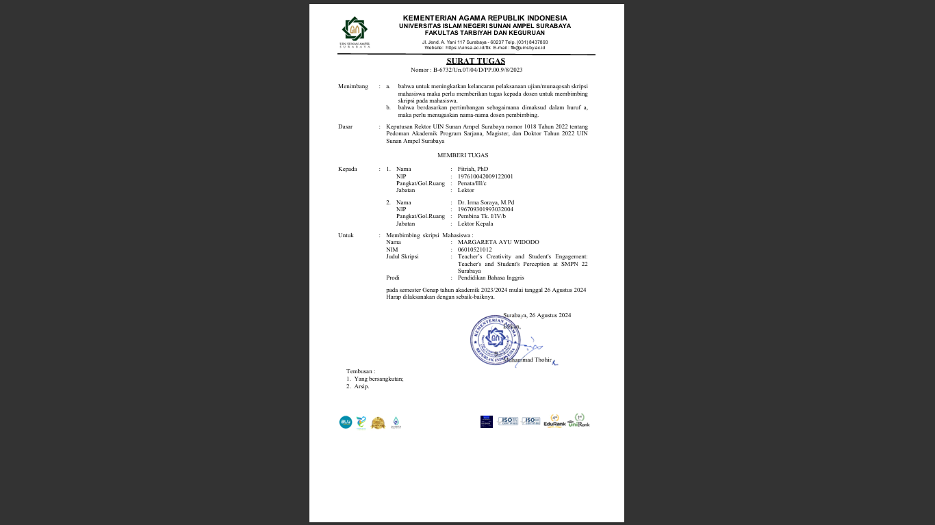

Appendix 5. Instrument Validation Sheet

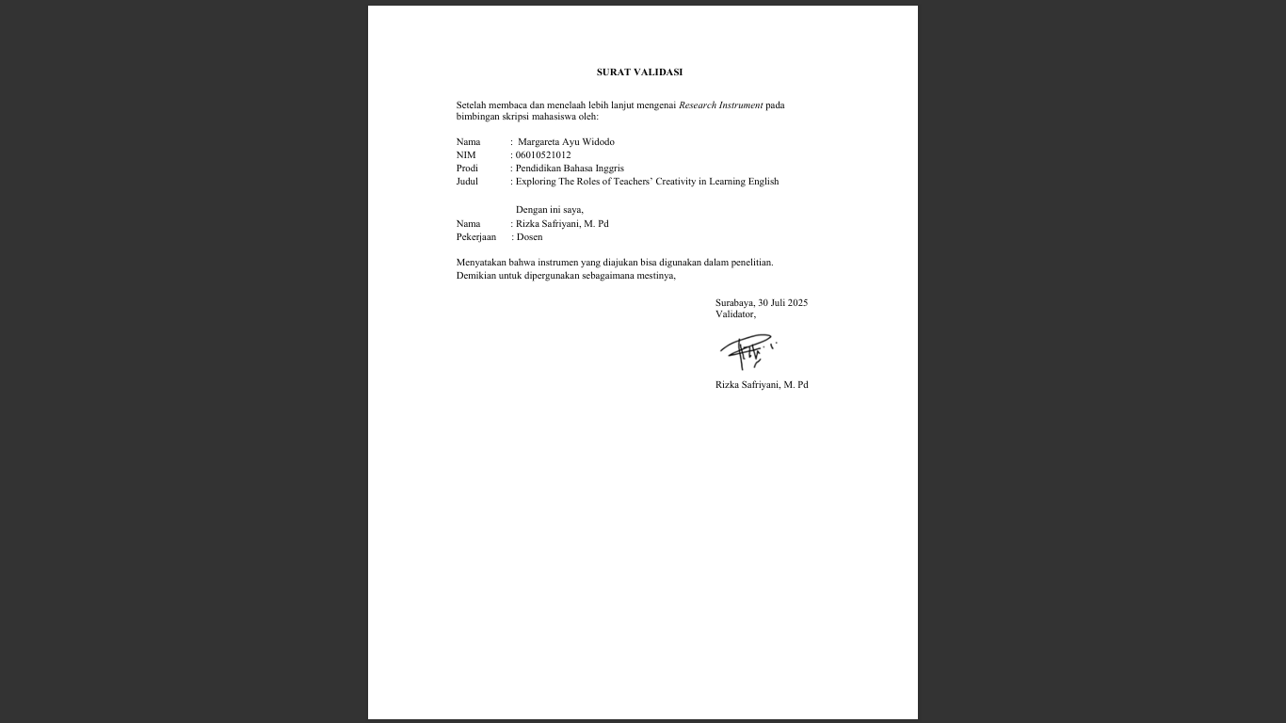

Appendix 6. Approval Sheet of Thesis Proposal

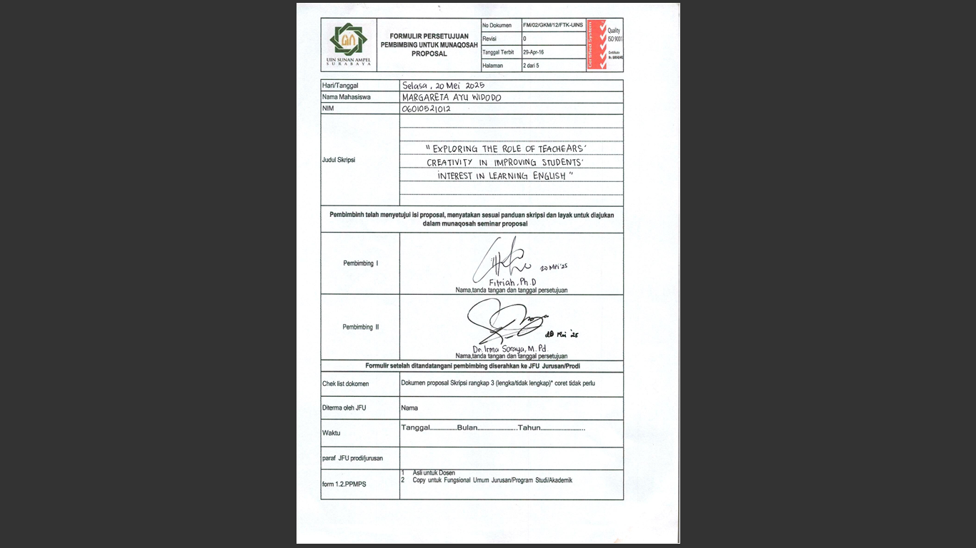

Appendix 7. Approval Sheet of Thesis

